Number 45 | April 2014

Summary | This newsletter describes recent enhancements to the National Student Loan Data System (NSLDS) and the NSLDS Professional Access Web site. The changes include:  - Enhancements to Support the 150% Direct Subsidized Loan Limit  - New Subsidized Usage Page  - Updates to Enrollment Reporting  - New NSLDS Enrollment Reporting Guide and Enrollment Reporting File Layouts  - NSLDS Enrollment Spreadsheet Submittal  - Enhancements to Enrollment Maintenance Page  - Removal of Enrollment Add Page  - New Enrollment Status “Q” (Three-Quarter Time)  - New Country Codes  - New Student Contact Information Page  - Enhancements to Accommodate Schools with Locations Greater than 99  - New Fields on the Loan Detail Page
Enhancements to Support the 150% Direct Subsidized Loan Limit | New Subsidized Usage Page  A link to the new Subsidized Usage page has been added under the Enrollment Summary page. This page displays information about a student's total subsidized usage, loan-level subsidized usage that is sent to NSLDS from the Common Origination and Disbursement (COD) System, and information about the programs in which the student is enrolled that is reported by a school to NSLDS under the enhanced file layouts (discussed below).  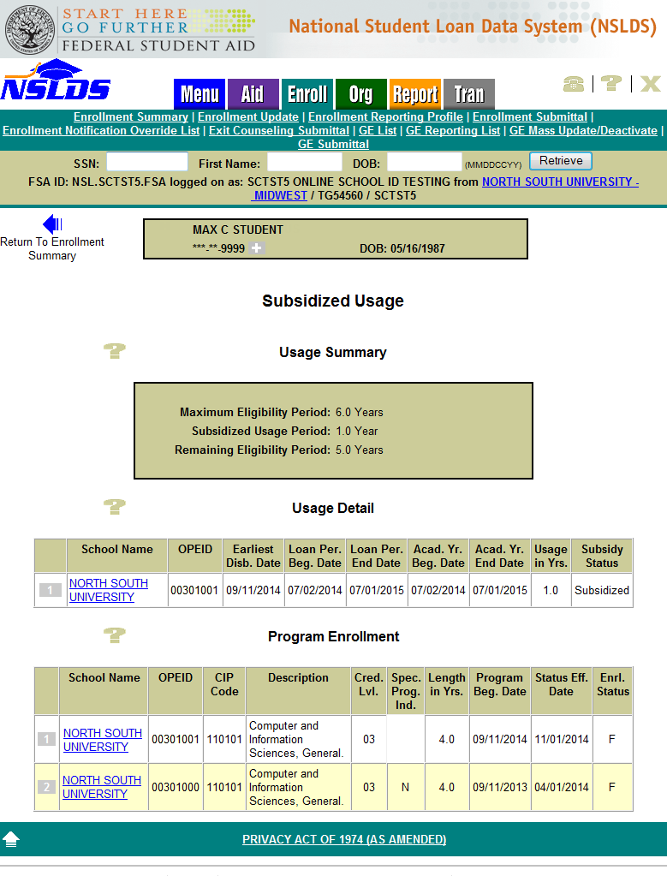
Updates to Enrollment Reporting | New NSLDS Enrollment Reporting Guide and Enrollment Reporting File Layouts  As a result of the 150% Direct Subsidized Loan Limit, schools will be required to report enrollment at the program level no later than October 1, 2014. For more information about changes to the requirements for institutional reporting of enrollment information to NSLDS, refer to Dear Colleague Letter GEN-14-07, posted to the Information for Financial Aid Professionals (IFAP) Web site on April 14, 2014.  To provide the community with technical details about these changes, a new version of the NSLDS Enrollment Reporting Guide will soon be available on the IFAP Web site, in the NSLDS User Documentation section. The Guide has been reformatted to be more clear and concise, and to add new guidance about program-level reporting.  In addition, we posted new NSLDS Enrollment Reporting file layouts (in fixed-width and comma separated values [CSV] formats) to the IFAP Web site on February 27, 2014, in the NSLDS Record Layouts section. Schools may begin using the new file layouts immediately. However, all schools must report enrollment records under the new reporting file layouts regardless of their method of reporting by October 1, 2014.  Important Note: While we encourage schools to implement the necessary changes as soon as possible, all schools must have implemented the necessary changes by October 1, 2014. This October date represents a three-month extension from our previously announced deadline of July 1, 2014. Schools that choose to wait to report using the new enrollment reporting file layouts until after July 1, 2014 must, when they do begin reporting using the new enrollment reporting file layouts, report program-level enrollment information retroactive to July 1, 2014.  As a reminder, the use of a third party servicer does not relieve the school of the responsibility for enrollment reporting. Use the monitoring tools and information in the Enrollment Reporting Guide to ensure that your school is in compliance with all enrollment reporting requirements.  Other notable changes to the enrollment reporting process are as follows:  - Beginning July 1, 2014, NSLDS will request enrollment information from schools every 60 days and schools will be required to respond to those requests within 15 days of the date that we send the electronic enrollment reporting roster to the school or to its designated third-party servicer. Therefore, all enrollment reporting schedules with frequencies greater than two months will be updated to the new default schedule of every two months.  - Beginning October 1, 2014, NSLDS will no longer accept files in the previous Original and Enhanced fixed-width or CSV formats. At the same time, NSLDS will stop accepting files in the XML format. Support for XML file exchange with a modified schema may resume at a later date.  - A new Enrollment Status of ‘Q’ for three-quarter time has been added as a valid value.  NSLDS Enrollment Spreadsheet Submittal  The Enrollment Spreadsheet Submittal Template and the Enrollment Spreadsheet Submittal Instruction Guide will not be changing at this time, but will be updated July 1, 2014 to allow schools to report enrollment at the program level and to provide e-mail address information for students.  The current Instruction Guide and Submittal Template are available in the "Software and Associated Documents" section of the Federal Student Aid Download (FSAdownload) Web site. Please monitor the IFAP Web site for a forthcoming communication regarding updates to this function.
Enhancements to Enrollment Maintenance Page
The Enrollment Maintenance page has been updated to allow schools to report program-level enrollment for students, and to add new students to a school’s roster.
To add a new program for a student, click the Add Program button, and then enter the required information. To certify the information, check the box at the top left of the student’s record (or click the “Check All” button at the top of the page) and then click the Certify Checked Students button at the bottom of the page. At least one student must be selected, in order for the Certify Checked Students button to become active.
Note that if a school reports program-level enrollment information online, and then submits a batch file in the current format (without the program-level enhancements), this will cause the program data reported online to be deleted.
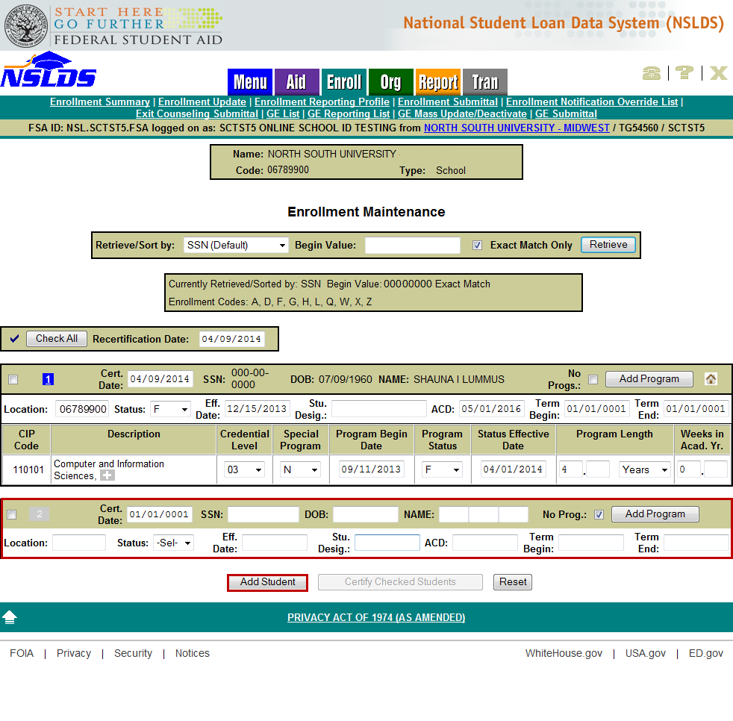
Removal of Enrollment Add Page
The Enrollment Add page has been removed from the NSLDS Professional Access Web site. Schools are now able to add students to their rosters on the Enrollment Maintenance page by clicking the Add Student button at the bottom of the page.
New Enrollment Status ‘Q’ (Three-Quarter Time)
We have implemented a new enrollment status code of ‘Q’ for students enrolled at least three-quarter time, but less than full-time.
The new enrollment status code of ‘Q’ has been added as a valid value to the campus and program-level enrollment reporting. After a ‘Q’ has been successfully reported, NSLDS will display the enrollment status on the following enrollment Web pages:
- Enrollment Summary
- Enrollment Detail
- Enrollment Timeline
- Enrollment Certifications by Quarter
Additionally, all scheduled and on-demand reports that contain enrollment status have been updated to include the new enrollment status ‘Q’.
Please refer to the upcoming new Enrollment Reporting Guide for detailed information about the online enrollment reporting functions available on the NSLDS Professional Access Web site.
New Country Codes
The Enrollment Reporting Guide, Enrollment Reporting file layouts (fixed-width or CSV), and Enrollment Reporting Notification file layouts have been updated to include the following country codes:
- BL – Saint Barthélemy
- BQ – Bonaire, Sint Eustatius and Saba
- CW – Curaçao
- GG – Guernsey
- IM – Isle of Man
- JE – Jersey
- ME – Montenegro
- MF – Saint Martin (French Part)
- RS – Serbia
- SS – South Sudan
- SX – Sint Maarten (Dutch Part)
New Student Contact Information Page | The Address History page under the Aid tab has been renamed Student Contact Information. This page now displays the student’s postal addresses, e-mail addresses, and phone numbers that have been reported to NSLDS. Schools are required to report contact information for students and they can use the Add Postal Address, Add Email Address, and Add/Update Phone Number buttons to report new information.  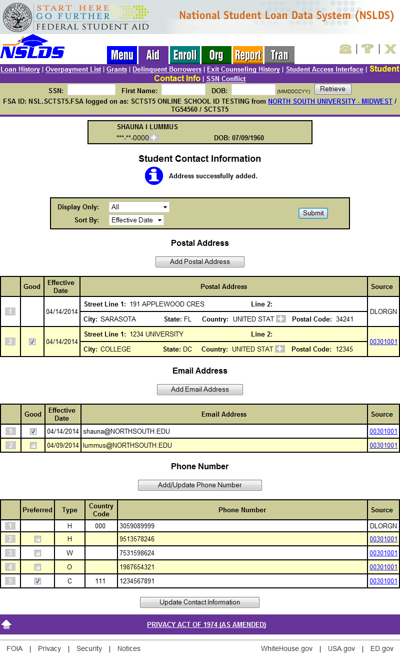
Enhancements to Accommodate Schools with Locations Greater than 99 | NSLDS will now accept and display institutions that have more than 99 additional locations. For locations with more than 99 locations, the first-digit of the Office of Postsecondary Education ID (OPEID) is incremented to ‘1’. If an institution has more than 199 additional locations, the first-digit is incremented to 2, etc.  Example:  - Institution: 067899 Location: 12 = Eight-digit OPEID: ‘06789912’  - Institution: 067899 Location: 175 = Eight-digit OPEID: ‘16789975’  - Institution: 067899 Location: 350 = Eight-digit OPEID: ‘36789950’  School Branch Code fields under the Aid, Enroll, Org, and Report tabs of the NSLDS Professional Access Web site have been modified from a two-digit field to an eight-digit field to incorporate this change.  AID TAB:  The Delinquent Borrowers page has been modified to allow the user to enter the eight-digit OPEID in the Branch Code field:  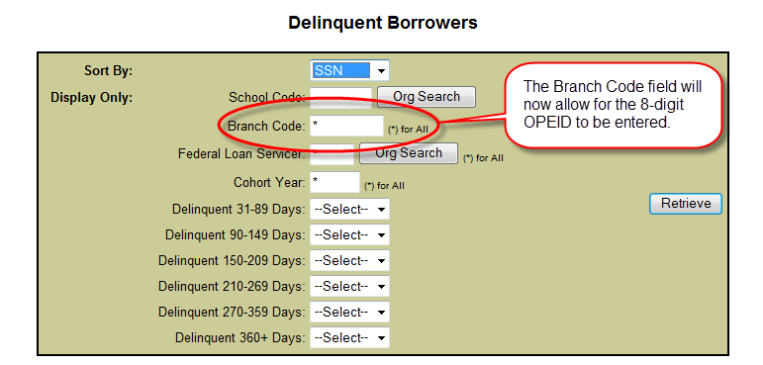  ENROLL TAB:  The Enrollment Reporting Profile page has been modified to display the eight-digit OPEID under the Enrollment Administration section:  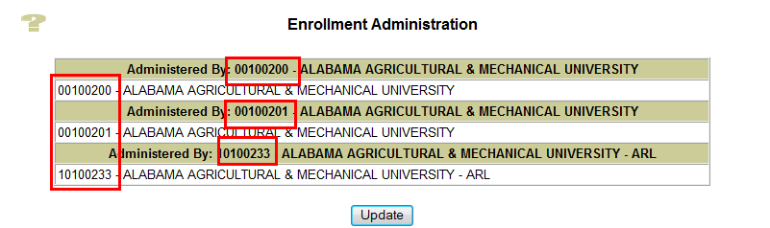  In addition to the Enrollment Reporting Profile page, the following pages under the Enroll tab have been updated:  - Ad Hoc Roster Request – Code Field  - Enrollment Administration Update – Location Field  - Enrollment Certification by Quarter – Display Location Field  - Enrollment Maintenance – Location Field  - Enrollment Update – Location Field  - GE List – Location Code Field  - GE Add – Institution Code (OPEID)  - GE Update – Institution Code (OPEID)  - GE Mass Update/Deactivate – Location Code  ORG TAB:  The Scheduled Reporting section on the School Profile page has been modified to display the eight-digit OPEID in the School Branch ID field, and also to allow users to enter the eight-digit OPEID when applicable.  For the Loan Exit Counseling Summary Profile Update page, the School Branch ID is now an eight-digit field:  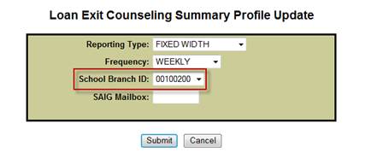  In addition to the Loan Exit Counseling Summary Profile parameters, the following scheduled reports under the School Profile page will be updated:  - Loan Exit Counseling Detail  - Loan Exit Counseling Summary  - TEACH Grant Exit Counseling Detail  - TEACH Grant Exit Counseling Summary  - Delinquent Borrower  - School Portfolio  REPORT TAB:  The Borrower Demographic Report parameter page will be modified to allow the user to enter the eight-digit OPEID in the School Branch ID field:  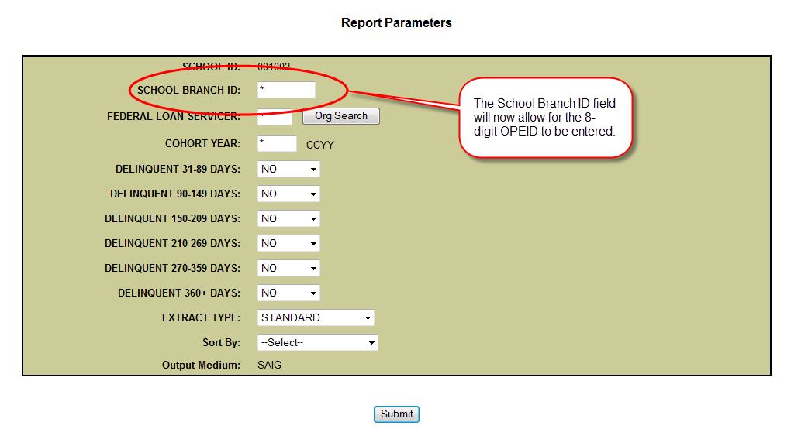  In addition to the Borrower Demographic Report, the following reports under the Report tab will be updated:  - DELQ01 – Delinquent Borrower Report  - GENEX1 – GE Data Extract File  - SCHPR1 – School Portfolio Report  - EXTCD1 – Loan Exit Counsel. Summary by Date  - EXTCS1 – Loan Exit Counsel. Summary by SSN  - EXTC01 – Loan Exit Counsel. Completion  - EXTD01 – TEACH Exit Counsel. Completion  - EXTSD1 – TEACH Exit Counsel. Summary by Date  - EXTSS1 – TEACH Exit Counsel. Summary by SSN  - PLPED3 – Status of Loans Purchased by ED  Ad-hoc and Scheduled Report File Extract Record Layouts  Although these system enhancements do not impact the length of the file layout extracts, definitions have been updated to clarify the school code and school location code field descriptions for schools that have more than 99 locations. The updated extract file layouts were posted on April 14, 2014 in the NSLDS Record Layouts section of the IFAP Web site and include:  - NSLDS Date Entered Repayment Report (DER001)  - Delinquent Borrower Report Extract Record Layouts for Schools (DELQ01)  - Loan Exit Counseling Extract Record Layouts for Schools:  - Completion Extract – Ad-Hoc (EXTC01)  - Completion Extract – Scheduled (EXTC05)  - Summary by Date Extract – Ad-Hoc (EXTCD1)  - Summary by SSN Extract – Ad-Hoc (EXTCS1)  - Summary Extract – Scheduled (EXTCD5)  - Borrower Demographic Report Extract File Layout for Schools (SCHBR1)  - Enrollment Reporting Certification Report Extract File Layout (SCHER4)  - Gainful Employment Data Extract File Record Layout (GENEX1)  - NSLDS Median Borrowing Backup Detail Report (SCHMB1)  - School Portfolio Report Extract File Layout for Schools (SCHPR1)  - Status of Loans Purchased By ED Report Extract File Layout for Schools (PLPED3)  - TEACH Grant Exit Counseling Extract Record Layouts for Schools:  - Completion Extract – Ad-Hoc (EXTD01)  - Completion Extract – Scheduled (EXTDP1)  - Summary by Date Extract – Ad-Hoc (EXTSD1)  - Summary by SSN Extract – Ad-Hoc (EXTSS1)  - Summary Extract – Scheduled (EXTSP1)
New Fields on the Loan Detail Page | The Loan Detail page, under the Aid tab, has been updated to show the Academic Year Begin date, Academic Year End date and Loan Last Updated date.  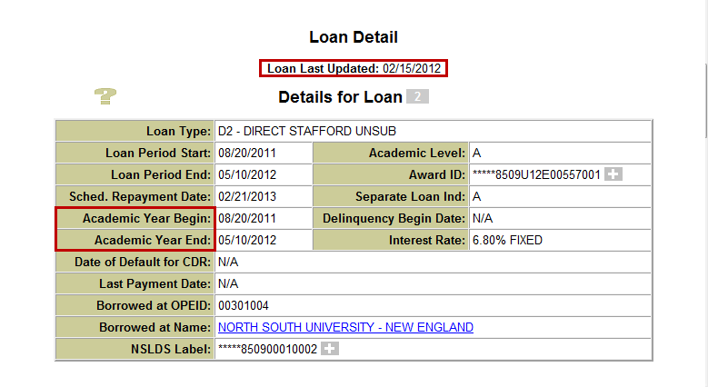
Supported Web Browsers and Customer Service Reminder | We recommend that users of the NSLDS Professional Access Web site use the supported browser Microsoft Internet Explorer (IE) Version 7 or lower. If you do not have this browser, it is recommended that you download it or select compatibility mode if you are using a browser greater than IE7. To provide a higher level of security, it is recommended that you use the 128-bit version of the browser. Some unsupported browsers may not be compatible with all features of the NSLDS Professional Access Web site.  Please remember to keep your NSLDS Professional Access Web site ORG contacts current and always list at least a Primary Contact for your organization. Additionally, it is important to include a Customer Svc (Borrowers) contact as the information is displayed on the NSLDS Student Access Web site and may be viewed by borrowers and other Federal Student Aid partners.  The NSLDS Customer Support Center at 800/999-8219 is available Monday through Friday from 8 A.M. to 9 P.M. (ET). You may also contact Customer Support by e-mail at nslds@ed.gov. Callers in locations without access to 800 numbers may call 785/838-2141.

