Number 47 | February 2015
Summary
This newsletter describes recent enhancements to the National Student Loan Data System (NSLDS) and the NSLDS Professional Access Web site. These changes include:
- 2015-2016 Eligibility Enhancements:
  - Updates to the Prescreening and Postscreening Processes
  - Updates to the Transfer Student Monitoring (TSM) and Financial Aid History (FAH) Process and Batch File Layouts
  - Update to the Aggregate Loan Limit Tolerance
- Enhancements to Enrollment Reporting Web Pages:
  - Enrollment Maintenance Page for Student Address Reporting
  - Enrollment Reporting Profile Preferences - File Type Options
- Gainful Employment Record Layouts Available
2015-2016 Eligibility Enhancements

Prescreening Process
New for the 2015-2016 Award Year is the addition of the Subsidy Status Date field to the NSLDS Financial Aid History section of 2015-2016 Institutional Student Information Records (ISIRs). The Subsidy Status Date is the date the loan interest subsidy status was confirmed by the loan servicer as reported to NSLDS. Refer to NSLDS Newsletter 46 for more information on the loan interest subsidy status.

Postscreening Process
The following Postscreening Reason Codes have been added to the 2015-2016 postscreening process to alert schools of changes to the Confirmed Loan Subsidy Status, which is the status of the interest subsidy on a loan, and decreases to the student’s Subsidized Usage Period:
- ‘26’ = Confirmed Loan Subsidy Status change
- ‘27’ = Subsidized Usage Period decrease changes only

TSM/FAH Process and Batch File Layouts
The new NSLDS Transfer Student Monitoring (TSM)/ Financial Aid History (FAH) User Guide and Batch File Layouts are available on the Information for Financial Aid Professionals (IFAP) Web site. The new User Guide provides step-by-step instructions for creating and managing the TSM list using the NSLDS Professional Access Web site, batch and report request instructions, as well as the updated TSM/FAH Batch file layouts for use beginning January 1, 2015.
Updates include:
- Updated field names:
  - From “Subsidized Limit Eligibility Used” to “Subsidized Usage Period”
  - From “Last Confirmed SULA Status” to “Confirmed Loan Subsidy Status”
- New fields:
  - Subsidy Status Date
  - Academic Year Begin and End Dates
- Added new Loan Limit valid value of “R” (Exceeded Loan Limit and Reaffirmed Debt) to the following fields:
  - Undergraduate Subsidized and Combined Loan Limit Flag
  - Graduate Subsidized and Combined Loan Limit Flag
- Relocation of the Unusual Enrollment History Indicator in the TSM/FAH Reports
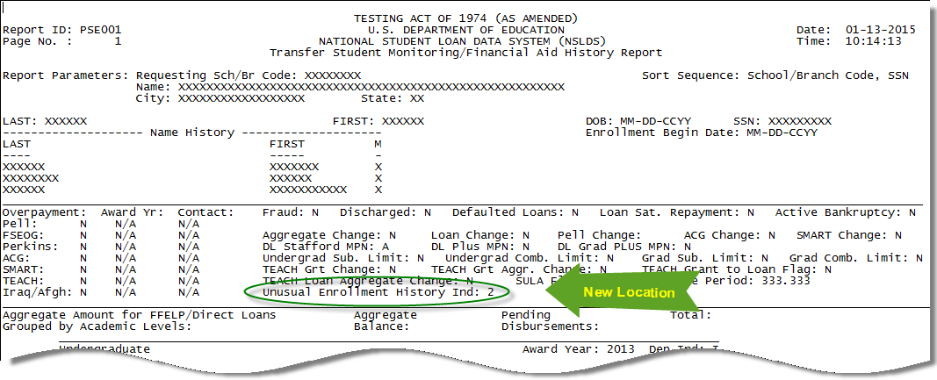
Additionally, we have provided the updated TSM/FAH Batch File Layouts as a separate document, for users who prefer to receive only the updated batch file layouts. Included in both the User Guide and the separate batch file layouts document is a “What’s New” section detailing the changes for the new award year.
Note: The field name updates have also been made to the NSLDS Financial Aid History section of the 2015-2016 ISIR.

Update to the Aggregate Loan Limit Tolerance
The NSLDS Professional Access Web site displays Aggregate Loan Limit Flags on the Loan History page for borrowers. NSLDS has lowered the tolerance built into the aggregate loan limits from $100 to $25. This tolerance amount of $25 applies to the total of all of the borrower’s loans by loan program type.
Enhancements to Enrollment Reporting Web Pages

Enrollment Maintenance Page for Student Address Reporting
The Enrollment Maintenance page has been updated to include an “Address” Button instead of the “House” icon. This change allows schools to submit postal address information without navigating to the Student Contact Information page.
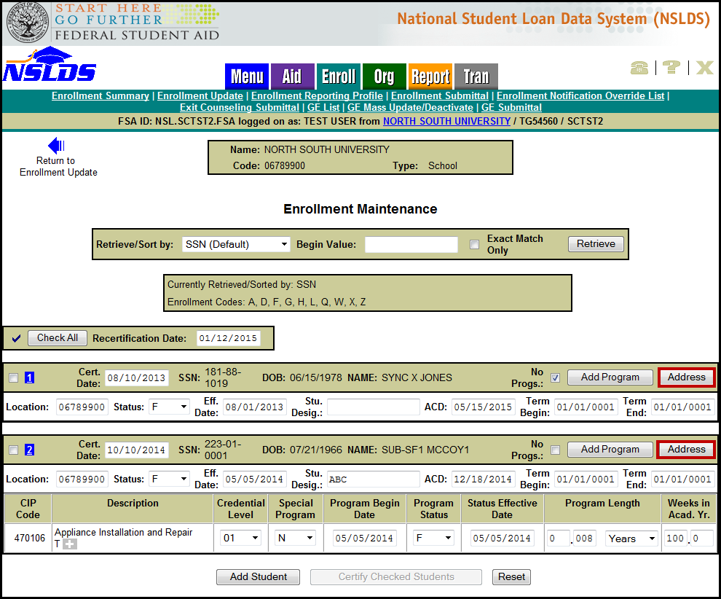
By clicking the “Address” button, a pop-up window for Student Permanent Address will display. If the school has previously reported the student’s permanent address to NSLDS, the pop-up window will be pre-populated. If the school has not reported an address for the student, the fields will be blank and ready for the school to add the address.
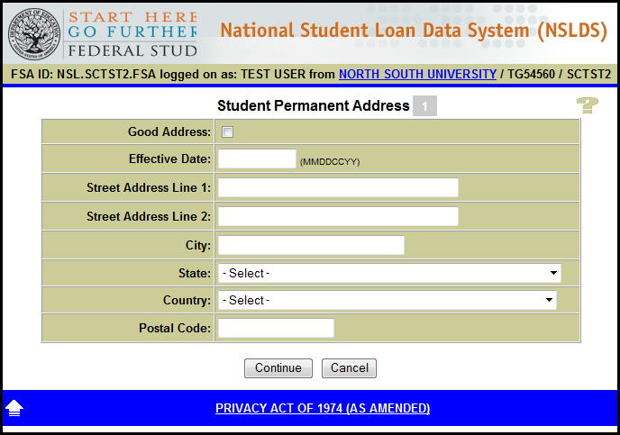

Enrollment Reporting Profile Preferences - File Type Options
The Enrollment Reporting Profile Preferences section has been updated to reflect only the reporting file type options currently available. The file types available are fixed-width and comma separated values (CSV). The CSV option can be selected to generate a roster in a format that is ready to be imported into the new Enrollment Spreadsheet Submittal Format. Additionally, the option to specify a date to start receiving the new file layout, which includes program-level enrollment fields, has been removed, as reporting of program-level has been required since October 1, 2014. For more information about compliance with program-level enrollment reporting requirements, refer to the December 23, 2014 electronic announcement posted to the IFAP Web site.
Gainful Employment Record Layouts Available
The updated NSLDS Gainful Employment Submittal File Record Layouts were posted to the IFAP Web site on January 9 in fixed width and comma separated values (CSV) formats. We will provide additional information in the near future regarding the submittal template, availability of reporting GE data, and the NSLDS GE User Guide. Also refer to the Gainful Employment Information Page for GE resources.
Customer Service Reminder
Please remember to keep your NSLDS Professional Access Web site ORG contacts current and always list at least a Primary Contact for your organization. Additionally, it is important to include a Customer Svc (Borrowers) contact as the information is displayed on the NSLDS Student Access Web site and may be viewed by borrowers and other Federal Student Aid partners.
The NSLDS Customer Support Center at 800/999-8219 is available Monday through Friday from 8 A.M. to 9 P.M. (ET). You may also contact Customer Support by e-mail at nslds@ed.gov. Callers in locations without access to 800 numbers may call 785/838-2141.

