Number 48 | July 2015
Summary
This newsletter describes recent enhancements to the National Student Loan Data System (NSLDS®), the NSLDS Professional Access Web site, and the NSLDS Student Access Web site to support the reporting and display of reaffirmation data. In the sections below we describe the following:
- Reaffirmation Data on NSLDS Professional Access:
  - Reaffirmation Reporting
  - Reaffirmation Icons
  - Reaffirmation History Page
- Reaffirmation Icon on the NSLDS Student Access Web site
- Reaffirmation and the Prescreening/Postscreening Process

Reaffirmation Data on NSLDS Professional Access

Reaffirmation Reporting
Dear Colleague Letter GEN-13-02, dated January 17, 2013, provides guidance regarding how students who have inadvertently received Title IV loan funds, under the William D. Ford Federal Direct Loan (Direct Loan) or Federal Family Education Loan (FFEL) programs, in excess of annual or aggregate loan limits, may regain Title IV eligibility. Under the Department’s regulations at 34 CFR 668.35(d), the student can either repay the amount or make satisfactory arrangements for repayment with their loan holder. The repayment arrangement requires the student to agree to repay the excess amount, in writing, to the loan holder. This arrangement is called “reaffirmation.” For complete information about the reaffirmation process and student eligibility, refer to GEN-13-02.

NSLDS has been enhanced to allow the reporting of reaffirmation agreements from lenders, lender servicers, and federal loan servicers for display on NSLDS and for reporting on the Institutional Student Information Record (ISIR). Schools may use the information displayed on NSLDS and contained on the ISIR when determining a student’s eligibility for additional Title IV aid.

NSLDS will alert schools to the presence of reaffirmation data with the use of icons on NSLDS Professional Access, a new “Reaffirmation History” Web page, and additional loan limit indicators on the ISIR for use in the NSLDS prescreening and postscreening processes.

Note: Reporting reaffirmation data to NSLDS is required of our federal loan servicers; reporting the information to NSLDS is optional for FFEL Program lenders and lender servicers.

Reaffirmation Icons
On NSLDS Professional Access, the Reaffirmation(s) informational icon will display at the borrower level when the borrower has an active reaffirmation for one or more loans as reported by the loan holder. The icon will display on the Loan History, Grant History, Overpayment History, Overpayment List, and the Student Access Interface Web pages.

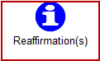
Additionally, on the Loan History page, a new icon will display next to the Loan Detail button for the reaffirmed loan. Clicking on this icon will link the user to the Reaffirmation History page for that specific loan.

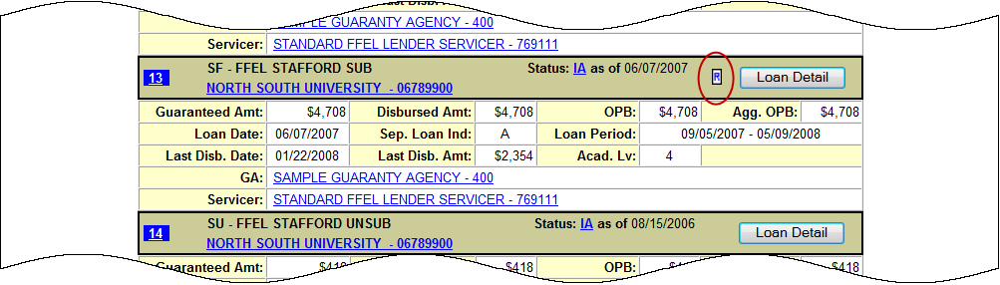

Reaffirmation History Page
The new Reaffirmation History page displays the history of reaffirmation(s) for loans that have been reaffirmed and reported to NSLDS. After selecting the icon next to the Loan Detail button, the Reaffirmation History page is displayed showing the reaffirmation details reported on that specific loan, as shown in the following screen shot example. Reaffirmation records display in descending order by Reaffirmation Begin Date.
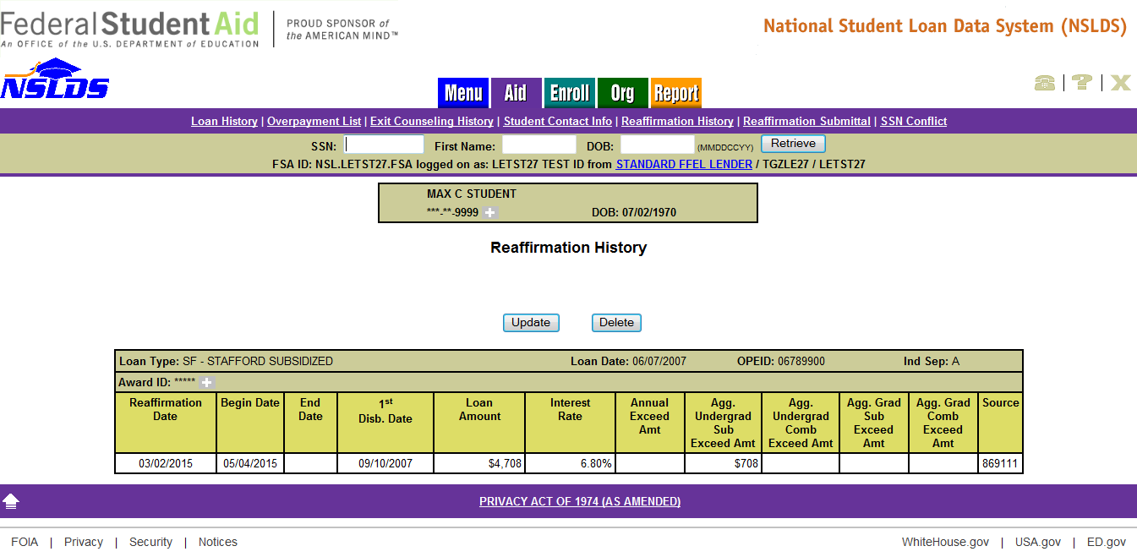
To view all reaffirmations reported to NSLDS for a specific borrower, select the Reaffirmation History link located under the Aid tab. The End Date field on the Reaffirmation History page indicates the date a reaffirmation record was deleted or updated causing the data to become “Inactive.” The reaffirmation record without an End Date is considered to be the “Active” (current) data reported. Only “Active” reaffirmation data should be used when evaluating a student’s eligibility for additional Title IV aid.

Reaffirmation Icon on NSLDS Student Access Web Site

Reaffirmation Icon
The new reaffirmation icon will display on the Financial Aid Review page of the NSLDS Student Access Web site next to each applicable loan once reaffirmation data has been reported. The reaffirmation date will display when the online user performs a mouseover on the icon.
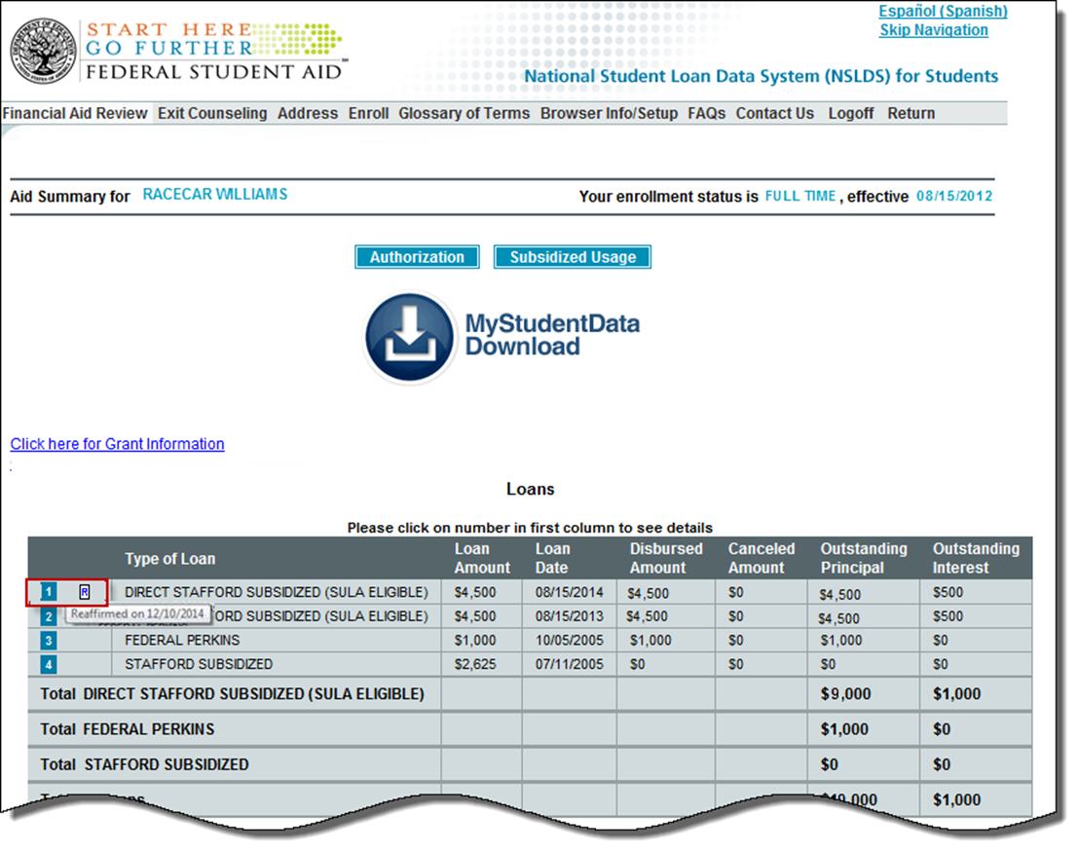

Reaffirmation and Prescreening/Postscreening
The value of “R” (exceeded loan limit and reaffirmed debt) has been added to the NSLDS Undergraduate Loan Limit Flag fields and the NSLDS Graduate Loan Limit Flag fields on the ISIR (fields 430-433). The “R” value will appear when there is an active reaffirmation on NSLDS for one or more loans of a student who has exceeded any of the aggregate loan limit types (undergraduate subsidized, undergraduate combined, graduate subsidized, and graduate combined).

The ISIR of a borrower who has exceeded any of the aggregate loan limits will have Loan Limit Flag value(s) of “E” (exceeds limit). New for the 2015-2016 Award Year, if the overborrowing is satisfied by repayment of the excess debt or if the reaffirmation of the excess debt is reported to NSLDS, a new ISIR transaction will be produced and the Loan Limit Flag value(s) of “E” will change to “R.” The transaction will contain NSLDS postscreening reason code “11 – exceeding subsidized loan limit resolved” or “12 – exceeding combined loan limit resolved”.

In addition, the new “R” Loan Limit Flag value triggers SAR comment codes 393 (undergraduate student) or 392 (graduate student). The school must review the student’s loan records on NSLDS to determine if the “R” value is shown on the loan or loans that resulted in excess borrowing. If so, the student regains eligibility to participate in the federal student aid programs.

If a borrower’s loan or loans again contribute to the student exceeding aggregate loan limit(s), potentially impacting the student’s federal aid eligibility since the last ISIR was produced, the corresponding Loan Limit Flag(s) will change from “R” to “E” (exceeds limit). A new ISIR transaction with NSLDS postscreening reason code “09 – exceeded subsidized aggregate loan limit” and/or “10 – exceeded combined aggregate loan limit” will be produced. In addition to the resulting ISIR, the NSLDS Professional Access Web site will display the corresponding warning and informational icons to help track the status of the borrower’s loan limits.

Customer Service Reminder
Please remember to keep your NSLDS Professional Access Web site ORG contacts current and always list at least a Primary Contact for your organization. Additionally, it is important to include a Customer Svc (Borrowers) contact as the information is displayed on the NSLDS Student Access Web site and may be viewed by borrowers and other Federal Student Aid partners.
The NSLDS Customer Support Center at 800/999-8219 is available Monday through Friday from 8 A.M. to 9 P.M. (ET). You may also contact Customer Support by e-mail at nslds@ed.gov. Callers in locations without access to 800 numbers may call 785/838-2141.

