Number 54 | June 2016
Summary
This newsletter describes recent enhancements to the NSLDS® Student Access website and provides an overview of existing functions on the site. This site provides valuable information to students regarding their aid and repayment information, enrollment, and subsidized loan usage, and allows them to view and update their contact information. This newsletter provides information about the following:
- Enhancements to NSLDS Student Access
  - Redesign of the Home page
  - Enhancements to the Enrollment page
    - Addition of Program Enrollment History
  - Enhancements to the Subsidized Usage page
    - Addition of Usage Detail
- Overview of Existing Functions
  - Financial Aid Review
  - Detail Loan Information Page
  - Student Contact Information
  - TEACH Grant Exit Counseling
- Student Access Interface
We encourage schools to inform their students about the information and resources available on NSLDS Student Access.
Enhancements to NSLDS Student Access

Redesign of Home Page
The home page of NSLDS Student Access has been redesigned to include a clear and complete listing of the functions available to students on the site, with buttons to take the student to each page. The top menu “ribbon” which appears on every page has also been updated to show all functions. When a student selects an option, they are taken to a login page, and then to the selected page. Once logged in, students can navigate to any page in the site. The home page also includes the “MyStudentData Download” button which allows a student to request a complete file of all their aid information.
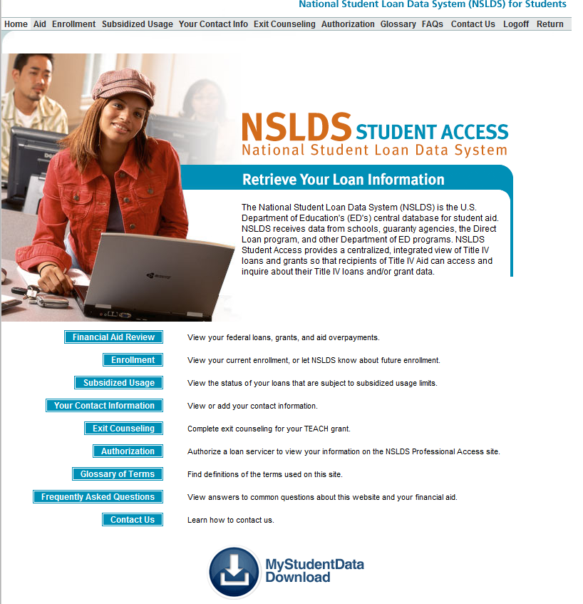

Enhancements to the Enrollment Page
The Enrollment page has been enhanced with the addition of program-level enrollment history. This allows the student to see the enrollment information that is used by NSLDS to determine the interest subsidy status of subsidized loans that are subject to the Direct Subsidized Loan Limit, for new borrowers on or after July 1, 2013. The student can also view the current campus-level enrollment status. The “Add a School” form on this site allows a student to tell NSLDS that they will be attending a new school, and to provide a date when the student will be attending. NSLDS will add the student to that school’s enrollment roster as of that date to request certified enrollment from the new school.
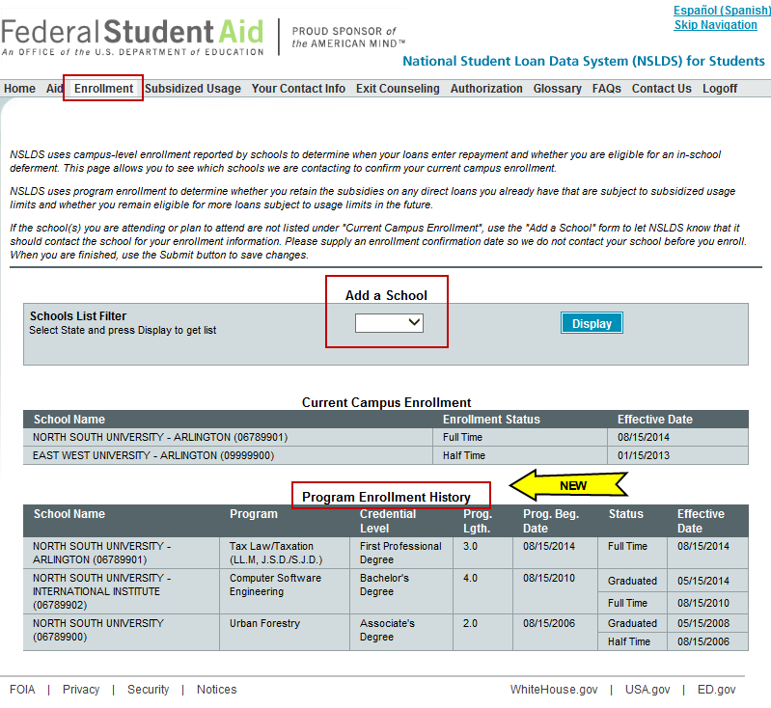

Enhancements to the Subsidized Usage Page
The Subsidized Usage page has been enhanced with the addition of Usage Detail. This lists all of the student’s Direct Subsidized Loans that are subject to the Direct Subsidized Loan Limit, along with the loan dates, usage in years, and the current interest subsidy status (Subsidized or Loss of Subsidy) for each loan.
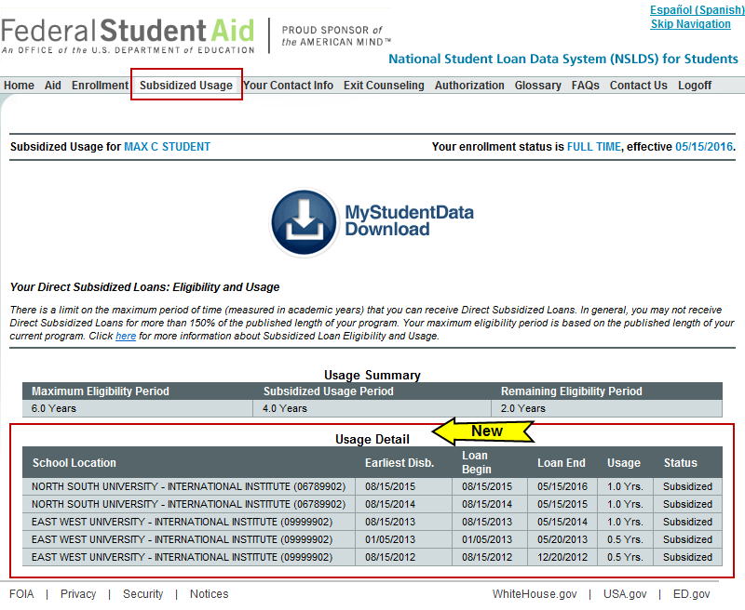

Overview of Existing Functions
Financial Aid Review
The Financial Aid Review page provides a summary of the student’s Title IV aid awards, including loans and grants. Students can access details of each aid award by clicking on the blue number in the left column.
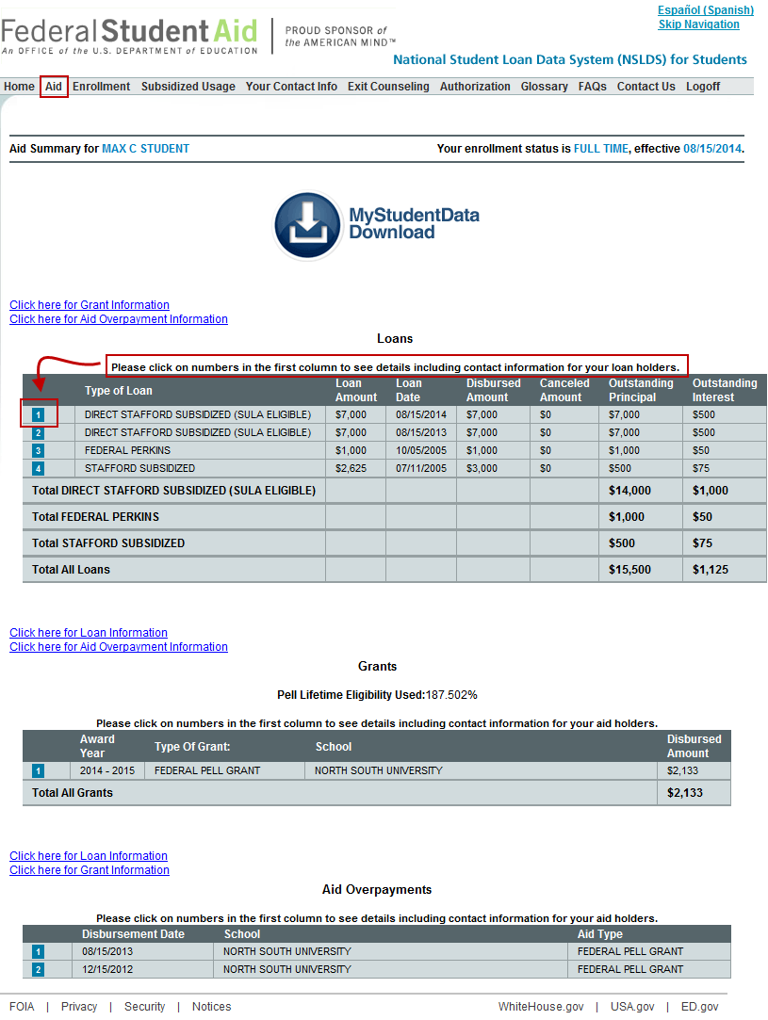

Detail Loan Information Page

NSLDS has recently added additional Detail Loan Information to the site, including Next Payment Due Date, Income-Driven Repayment (IDR) Plan Anniversary Date, Most Recent Payment Effective Date, Repayment Plan Type, and Public Service Loan Forgiveness (PSLF) Cumulative Matched Months. This page also displays other information about each loan, including balances, interest rate, key dates, and loan servicer contact information.

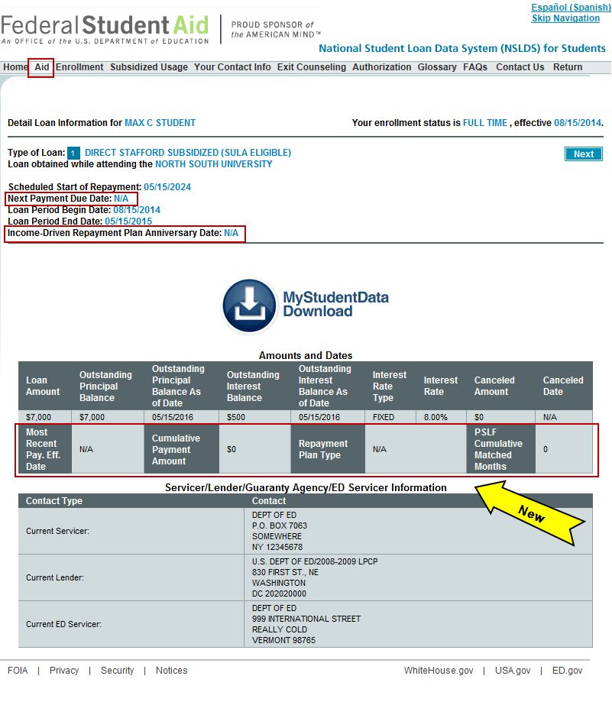

Student Contact Information
This page allows a student to provide NSLDS with new/updated contact information including address, e-mail, and phone numbers.
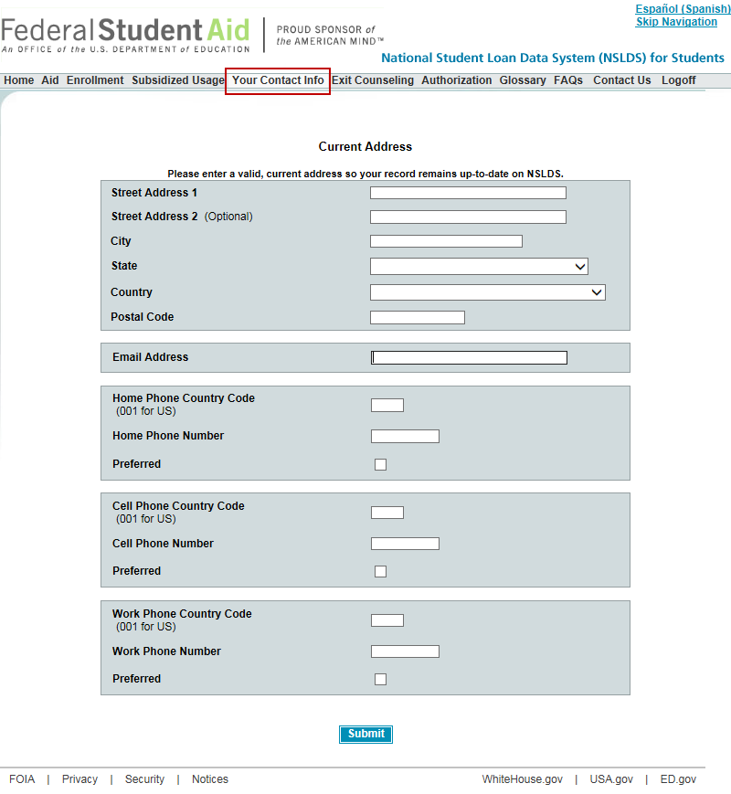

TEACH Grant Exit Counseling

Students may take TEACH Grant Exit Counseling on NSLDS. Students or other interested parties may also take a “tour” of the counseling from this page without logging in. This page also allows a student to be redirected to the StudentLoans.gov website if they need to take Loan Exit Counseling.
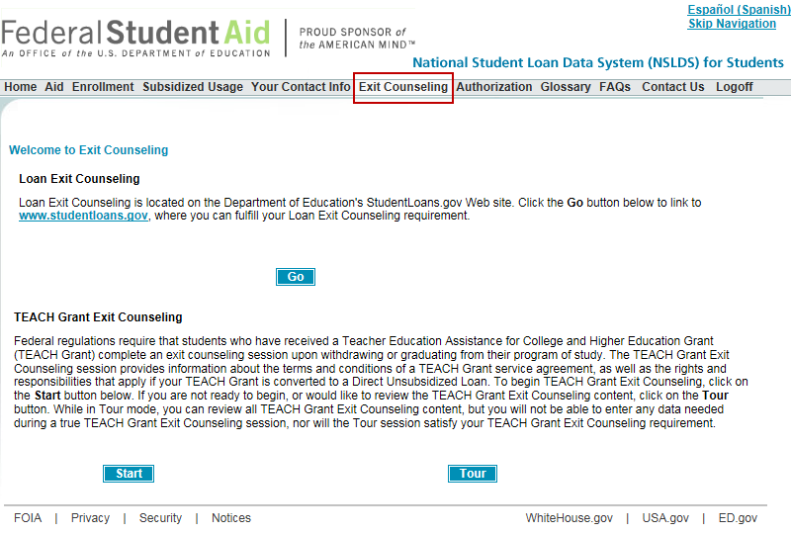
Student Access Interface
Schools may view a student’s information on the Student Access site by linking from NSLDS Professional Access using the Student Access Interface function. Click on Student Access Interface from the Menu tab, enter the student identifiers, and click on the Link button.
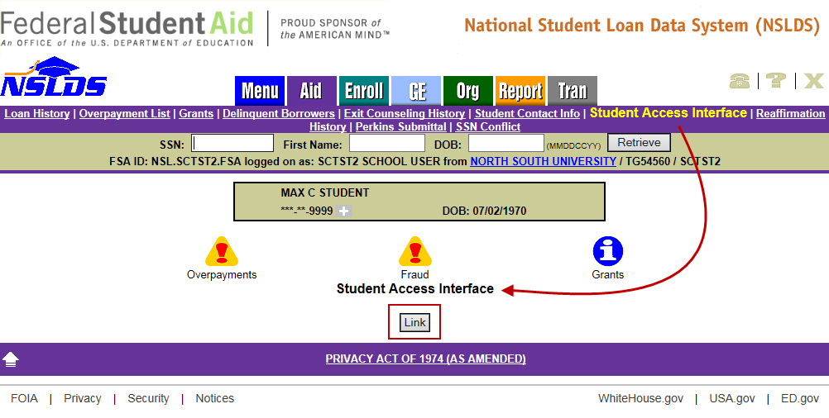
This will take you to the Aid Summary page of the Student Access site. Schools may then navigate around the site using the menu ribbon, and view all of the student’s info as displayed on the site. To return to the Professional Access page, click Return at the far right of the menu ribbon.
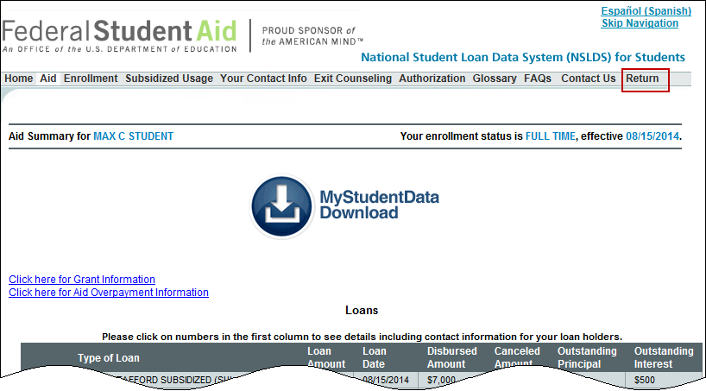
Customer Service Reminder
Please remember to keep your NSLDS Professional Access ORG contacts current and always list at least a Primary Contact for your organization. It is important to include a Customer Svc (Borrowers) contact as the information is displayed on the NSLDS Student Access website and may be viewed by borrowers and other Federal Student Aid partners.
Additionally, please ensure your school has an Enrollment Reporting contact listed so important notifications related to enrollment reporting compliance are received.
The NSLDS Customer Support Center at 800/999-8219 is available Monday through Friday from 8 A.M. to 9 P.M. (ET). You may also contact Customer Support by e-mail at nslds@ed.gov. Callers in locations without access to 800 numbers may call 785/838-2141.

