Number 57 | February 2017
Summary
This newsletter describes recent enhancements for school users to the National Student Loan Data System (NSLDS) and the NSLDS Professional Access website. These changes include:
- Organization Profile Page– New!
  - Overview of Organization Profile Page
  - How to Schedule Reports
  - Batch Services Display
  - School Transfer Profile
- Enhancements to NSLDS Reports
  - Ad Hoc and Scheduled Report Enhancements
- Report Tab Enhancements
  - Report List
  - Web Report List
Organization Profile Page - New
Overview of Organization Profile Page
The new Organization Profile page can be accessed through the Org tab of the NSLDS Professional Access website. This page allows users to view scheduled reports, batch services, and the Transfer Student Monitoring (TSM) Profile.
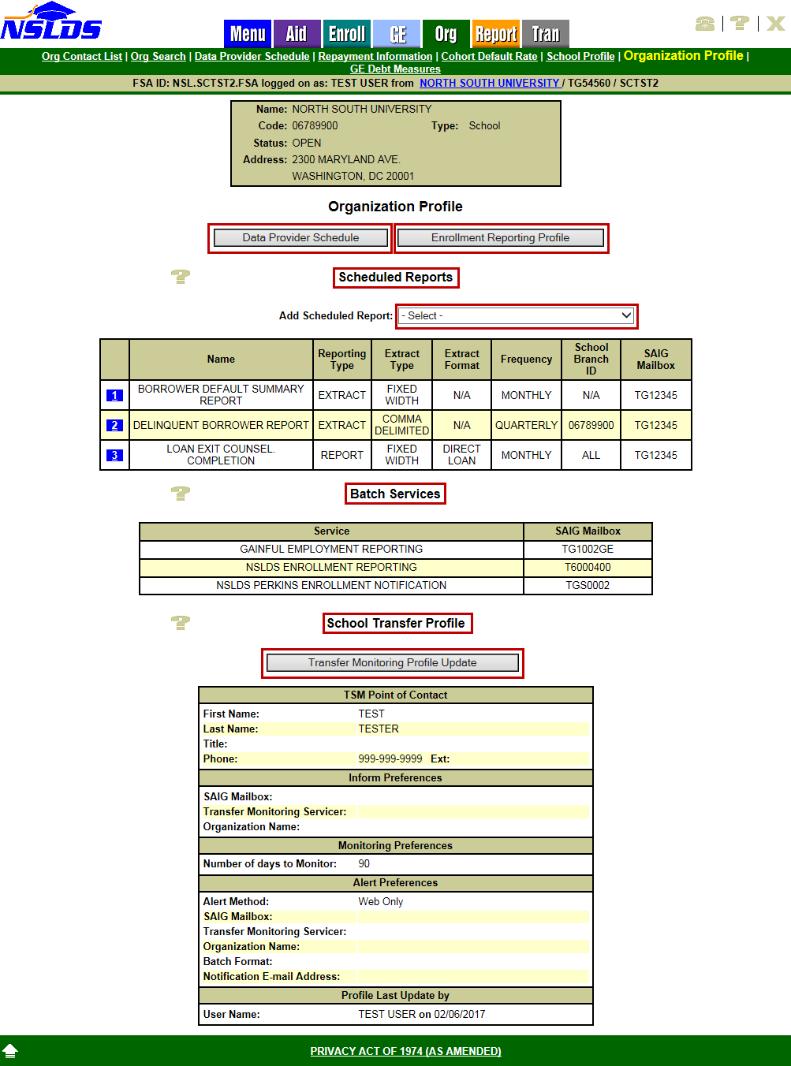
Users may access the Data Provider Schedule and Enrollment Reporting Profile pages by clicking on the associated buttons.
The Scheduled Reports section displays scheduled reports the school has chosen to schedule. For those reports not previously scheduled, users can select the report from the Add Scheduled Report drop down box. Once a scheduled report has been established, parameters for existing scheduled reports can be updated by clicking on the active bullet number icon next to the report name. Additionally, users can schedule, or modify, reports through the Report List and Web Report List web pages. Some of these reports were previously available for scheduling on the School Profile page, but the scheduling functionality has been moved to the Organization Profile page.
The Batch Services section displays the name of each NSLDS Service which the location is signed up for via the SAIG Enrollment Site.
The School Transfer Profile section displays the current Transfer Student Monitoring (TSM) Profile for the school. To update the TSM Profile, click on the Transfer Monitoring Profile Update button. When a TSM Profile is not present on the Organization Profile page, users have the option to add a TSM Profile by clicking on the Transfer Monitoring Profile Add button.
For more information about some of the features of the new Organization Profile page, refer to the sections below.
How to Schedule Reports
School users have the option to schedule some of the reports which are available on the Report tab of the NSLDS Professional Access website. Scheduling reports allows for automatic delivery based on the school’s frequency preference of daily, weekly, bi-weekly, monthly, or quarterly. Frequency options vary by report. Schools with no scheduled reports will see the following message displayed under the Scheduled Reports section on the Organization Profile page:
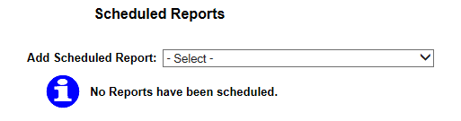
To schedule a report, click on the Add Scheduled Report drop down arrow and select a report.
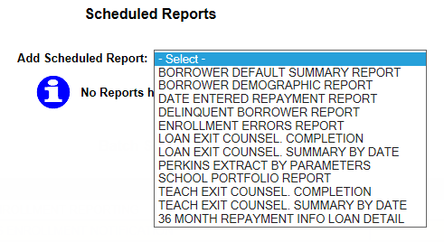
Selecting a report takes the user to the Profile Update page for the designated report. Once on the Profile Update page, the user enters desired parameters and submits. Users can also access the Profile Update page for a specific report through the Report List and Web Report List under the Report tab.
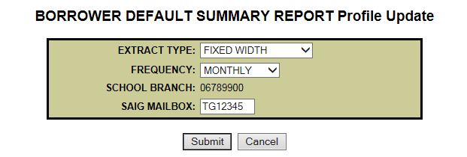
Once scheduled, the report is displayed under the Scheduled Reports section of the Organization Profile page.
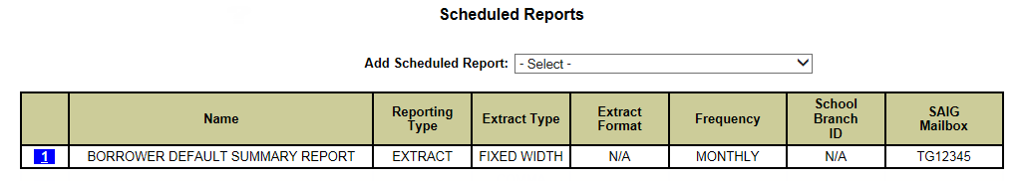
To update parameters of a scheduled report, click on the active bullet number icon next to the name of that scheduled report. The user will be redirected to the Profile Update page to make parameter updates and submit. The updated parameters will display under the Scheduled Reports section of the Organization Profile page, as seen above.
Batch Services Display
The Batch Services section displays the name of each NSLDS Service which the location is signed up for via the SAIG Enrollment Site. This information is fed to NSLDS for use and display, including the SAIG Mailbox associated with that service.
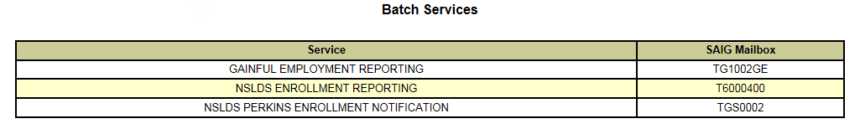
School Transfer Profile
The School Transfer Profile display and Update page has been moved from the Tran tab to the new Organization Profile Page.
For schools with no TSM Profile set up, click on the Transfer Monitoring Profile Add button displayed on the Organization Profile page.
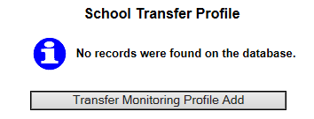
Complete the school’s TSM Profile from the School Transfer Profile Update page. Once all of the information is added, click Submit. Once you submit, you will be redirected to the Organization Profile page.
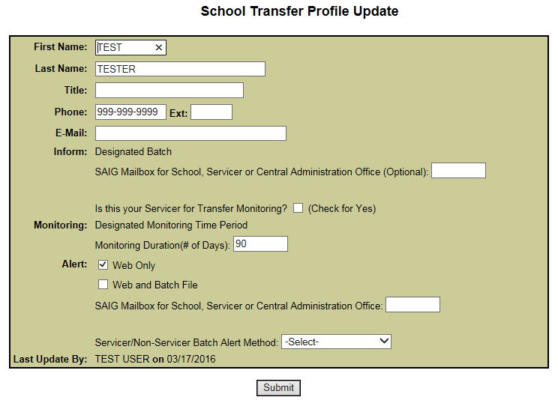
To update the school’s TSM Profile, click the Transfer Monitoring Profile Update button to be redirected to the School Transfer Profile Update page. Make necessary updates and click Submit.
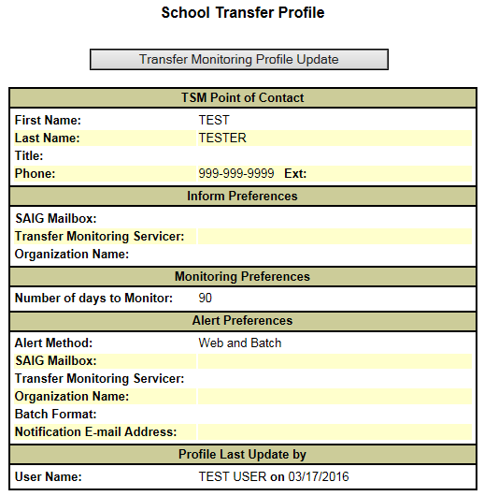
Note: An updated Transfer Student Monitoring & Financial Aid History User Guide & Record Layouts document will be posted to the Information For Financial Aid Professionals (IFAP) website in the near future.
Enhancements to NSLDS Reports

Ad Hoc and Scheduled Report Enhancements
The following reports can now be scheduled in both Comma Separated Values (CSV) and Fixed-width formats. To request a CSV formatted report, select Comma Delimited as the output type and to request a Fixed-width report, select Standard as the output type. Additionally, the reports can also be requested in CSV format for Ad hoc requests. Report IDs identify whether a report was requested as ad hoc or as a scheduled report. The Report ID, when present, is located in the header record. The following reports have unique Report IDs for ad hoc and scheduled report requests. The list below also identifies the SAIG message classes associated with each report and corresponding format types, and indicates which message classes are new:

Borrower Demographic Report

Updated CSV format to include a header and trailer record

Message classes: DEMOFWOP (Fixed-width) and DEMOCDOP (CSV)

Report IDs: Ad Hoc (SCHBR1) and Scheduled (SCHBR4)
- Borrower Default Summary Report
  - NEW! Message classes: SRPDF1OP (pre-formatted report), SFWDF1OP (Fixed-width) or SCDDF1OP (CSV) (Note: This report output will no longer be sent in the message classes previously used.)

Report IDs: Ad Hoc (SCHDF1) and Scheduled (SCHDF3)
- Date Entered Repayment Report
  - NEW! Message classes: SDERRPOP (pre-formatted report), SDERFWOP (Fixed-width) or SDERCDOP (CSV) (Note: This report output will no longer be sent in the message classes previously used.)

Report IDs: Ad Hoc (DER001) and Scheduled (DER003)
- 36 Month Repayment Info Loan Detail Report
  - Message classes: SHNOTROP (pre-formatted report), SHNOTEOP (Fixed-width) or NEW! SHNOTCOP (CSV)

Report IDs: Ad Hoc (DRC016) and Scheduled (DRC017)
- Enrollment Reporting Errors Report
  - Message classes: EFERFWOP (Fixed-width) or EFERCDOP (CSV)
  - Report IDs: Ad Hoc (SCHER5) and Scheduled (SCHER7)
Reminder: The Perkins Extract by Parameters Report output is sent in the message class SCHRECOP for both Ad Hoc and Scheduled reports.

Note: All ad hoc reports are sent to the SAIG Mailbox associated with the FSA User ID that made the request. All scheduled reports are sent to the SAIG Mailbox designated under the Scheduled Reports section of the Organization Profile page.

NSLDS Record Layouts are available in the NSLDS Reference Materials section of the IFAP website.

Additional hints for printing pre-formatted reports in Microsoft Word format are available on the Report List Help page on the NSLDS Professional Access website.
Report Tab Enhancements
Report List
The Report List on the NSLDS Professional Access website has been enhanced to display which reports the school has or has not scheduled. A red “S” icon displayed indicates scheduling has yet to be established while a green “S” icon displayed indicates scheduling has already been established. Not all schedulable reports are required to be scheduled, but have been made available for scheduling if the school prefers to receive the report data on a recurring basis. If an “S” icon does not appear in the Schedule column, the report is not available for scheduling. Clicking on a red or green “S” icon redirects users to the Profile Update page for the corresponding report. Once on the report’s Profile Update page, the user can add or update the parameters accordingly. After clicking on the submit button, the user will be redirected to the Organization Profile page.
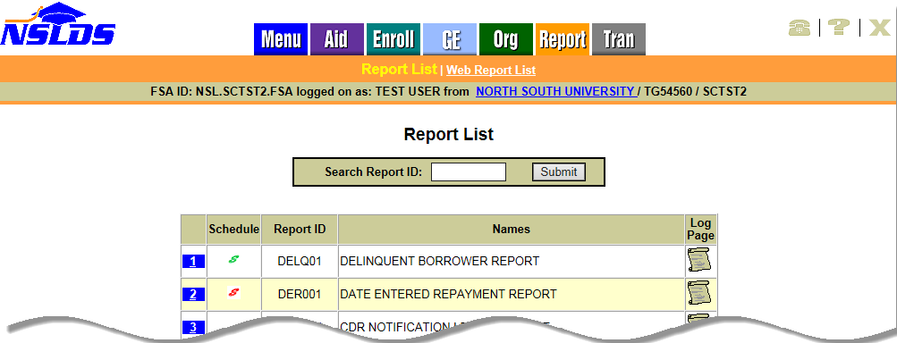
Web Report List
The Web Report List has also been enhanced to display which reports the school has or has not scheduled. A red “S” icon displayed indicates scheduling has yet to be established while a green “S” icon displayed indicates scheduling has already been established. If an “S” icon does not appear in the Schedule column, the report is not available for scheduling. Clicking on a red or green “S” icon directs user to the Profile Update page for the corresponding report. Once on the report’s Profile Update page, the user can add or update the parameters accordingly. After clicking on the submit button, the user will be directed to the Organization Profile page.
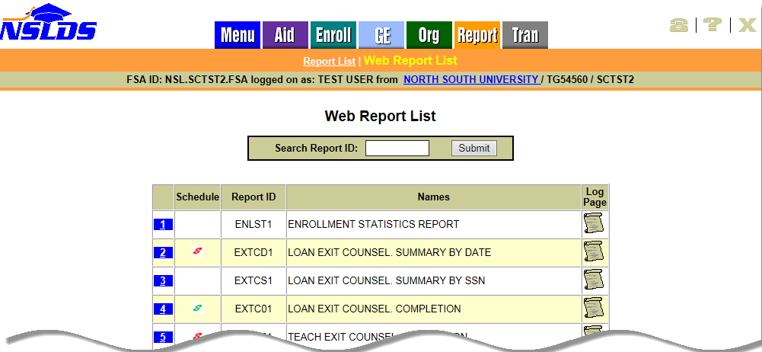
Customer Service Reminder
Please remember to keep your NSLDS Professional Access website ORG contacts current and always list at least a Primary Contact for your organization. It is important to include a Customer Svc (Borrowers) contact as the information is displayed on the NSLDS Student Access website and may be viewed by borrowers and other Federal Student Aid partners.
Additionally, please ensure your school has an Enrollment Reporting contact listed so important notifications related to enrollment reporting compliance are received.
The NSLDS Customer Support Center at 800/999-8219 is available Monday through Friday from 8 A.M. to 9 P.M. (ET). You may also contact Customer Support by email at nslds@ed.gov. Callers in locations without access to 800 numbers may call 785/838-2141.

