Number 58 | April 2017
Summary
This newsletter describes recent enhancements for school users of the National Student Loan Data System (NSLDS®) and the NSLDS Professional Access website. These changes include:
- Enrollment Reporting (ER) Enhancements
  - ER Program Level Certification Report (SCHER8)
  - NSLDS-COD Program Comparison Report (SCHE10)
- Enrollment Reporting Compliance Notifications
- Enrollment Reporting Statistics Reminder
- Award ID Search
Enrollment Reporting (ER) Enhancements
ER Program Level Certification Report
The ER Program Level Certification Report (SCHER8) provides school users with an extract of certified historical program-level enrollment data for students on the school’s roster. The user may choose to receive all data associated with their school by leaving the asterisk (*) in the School Location Code field, or only data for a single location by entering the eight-digit OPEID for that location. The user indicates the Roster Activity Date, which limits the report to a specific date when students were active on the school’s roster. The report output is sorted by Student SSN or by School Location Code and Student SSN. The processed data is sent to the SAIG mailbox associated with the NSLDS User ID that requested the report. Extract file output is sent with message classes ERCCCDOP for a Comma Separated Values extract layout or message class ERCCFWOP for a Fixed-Width extract layout. NSLDS Record Layouts are available in the NSLDS Reference Materials section of the IFAP website.
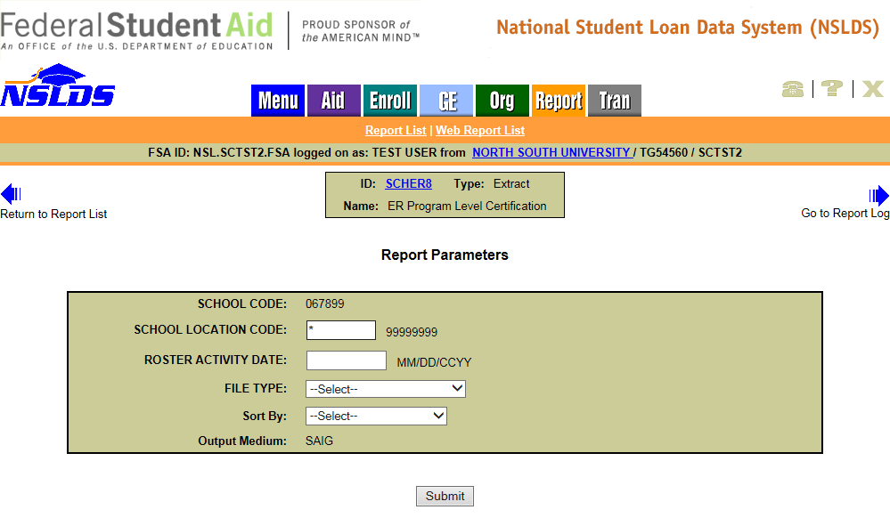

NSLDS-COD Program Comparison Report
The NSLDS-COD Program Comparison Report (SCHE10) provides school users with a comparison of NSLDS program-level enrollment data to Common Origination and Disbursement (COD) System program-level data. This report can provide insight into cases where the school has reported program-level data for a student to both the COD System and to NSLDS but the Credential Level and/or Published Program Length differ. The report can also identify when NSLDS has received program-level data from the COD System, but that data has not been certified by the school in its NSLDS enrollment reporting. Additionally, the report can include students for whom the school has reported conflicting program-level enrollment data. The user may choose to receive all data associated with their school by leaving the asterisk (*) in the School Location Code field or only data for a single location by entering the eight-digit OPEID for that location. The user indicates the Roster Activity Date, which limits the report to a specific date when students were active on the school’s roster. The report output is sorted by SSN. The report displays on-demand in a browser window using Excel format. Reports sent to the user’s TG Mailbox are sent in the message class ERCDCDOP (Comma Separated Values extract layout) or message class ERCDFWOP (Fixed-Width extract layout).
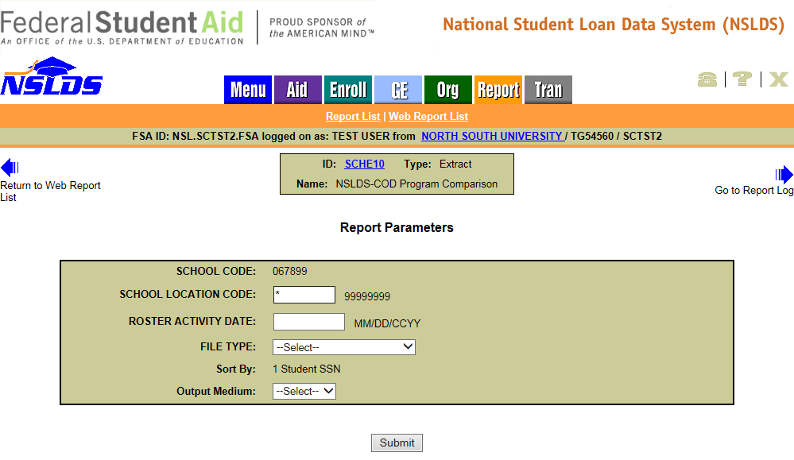
The NSLDS-COD Comparison Report will generate one or more detail records when conflicting program-level enrollment data exists for a student. When program-level enrollment data has been reported to NSLDS by the COD System but not certified by the school, there will only be one detail record for the student (see Max’s data in example screen shot below). When there is a conflict with the Credential Level and/or Published Program Length between the COD System and school certified data, there will be multiple detail records (see Sync’s data). Additionally, when the school has conflicting program-level enrollment data, there will be multiple detail records (see Felice’s data). The differences can best be determined by assessing the following fields: CIP Code (8th column below), Credential Level (10th column below), Published Program Length (11th column below), and Reporting Source Type (15th column below). NSLDS Record Layouts are available in the NSLDS Reference Materials section of the IFAP website.
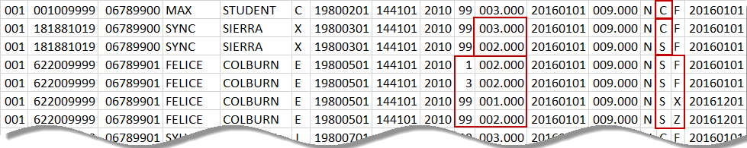
Enrollment Reporting Compliance Notifications
Enrollment Reporting Compliance Notifications
NSLDS will begin sending Enrollment Reporting Compliance Notifications to schools that are not reporting program-level enrollment information for a sufficient portion of their students. NSLDS tracks whether a school has reported program-level enrollment information for at least 90% of the students on its Enrollment Reporting roster. When NSLDS determines that a school does not meet the 90% minimum threshold, the school will receive an initial warning notification from NSLDS@ED.GOV, addressed to the school’s Financial Aid Administrator (FAA) Contact, as stored in NSLDS, as well as to the Enrollment Reporting Contact as provided on the ORG tab of the NSLDS Professional Access website. If your school has not yet provided an Enrollment Reporting Contact for each of its locations, such as a representative from the registrar’s office, please do so as soon as possible. Note that this contact cannot be someone from a school’s third party servicer. Schools will receive a separate Enrollment Reporting Compliance Notification for each of its locations that are under the 90% threshold.
If the school’s reporting performance does not improve the school will receive a second warning notification addressed to the FAA and to the Enrollment Reporting Contact, with the school’s President or CEO copied. If the school’s performance still does not improve after two warning notifications, it will receive a third notification that the school has been referred to the Department’s Federal Student Aid Program Compliance office for consideration of possible sanctions. This third notification will be addressed to the school’s President/CEO, with copies to the school’s Financial Aid Administrator and Enrollment Reporting Contact.

The program-level reporting threshold is set at 90% to allow for instances where a school may have a small percentage of the students included on its NSLDS Enrollment Reporting roster who are not enrolled in academic programs. While these students are not receiving aid at the reporting institution, they are enrolled in, for example, continuing education coursework.
If, after the school receives its initial notification, its believes that a significant percentage of its students are legitimately not enrolled in an academic program and, therefore, are properly reported only at the campus level and not at the program level for those students, the school should send an email requesting an Enrollment Reporting Compliance Notification Exception. The email should be sent to ERCompliance@ed.gov.
The Enrollment Reporting Statistics page, which is accessible through the Enrollment Reporting Profile, contains an Enrollment Compliance Notification History section. This section displays information about compliance notifications sent to an individual school location or to all the locations of the school. Additionally, school users can view the Enrollment Reporting Compliance Notification letter in its entirety online.
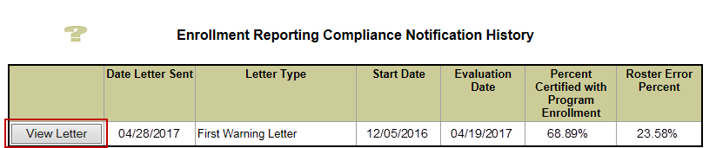
Enrollment Reporting Statistics Reminder
Enrollment Reporting Statistics Reminder
The Enrollment Reporting Statistics page displays information about the extent and quality of the school’s enrollment reporting to NSLDS. School users can view the previous 12 months of enrollment reporting statistics for the user’s school as a whole or for any of the school’s locations. Definitions for the columns displayed in the Certification Statistics for Location table are available on the Enrollment Reporting Statistics Help page.
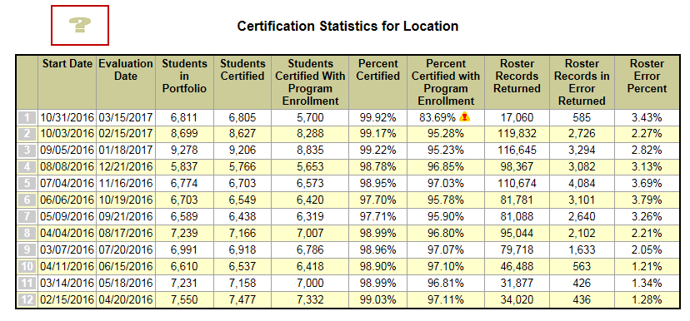

NSLDS determines “The Percent Certified with Program Enrollment” by calculating the number of students on the roster (“Students in Portfolio”) on the Start Date and students who were certified with Program enrollment at least once between the Start Date and Evaluation Date.
Please keep in mind that recent certifications may cause students included in the evaluation period to fall off the roster. Refer to a roster created closest to the Enrollment Reporting Statistics Start Date to determine which students were likely included in the calculation of Enrollment Statistics for that evaluation period. Schools may also run the existing Enrollment Certification Report (SCHER4) using an extract date set to the Start Date to see what students were on the roster as of that date.
The Enrollment Reporting Statistics process each month looks back 135 days from the Evaluation Date, and evaluates only students who were on the school’s roster as of the Start Date. Therefore, it may take multiple cycles for a higher reporting percentage to be reflected in the ‘Percent Certified with Program Enrollment’ column. As school users continue to certify students with program information they should see an increase in the institution’s program-level Enrollment Reporting Statistics in subsequent evaluation periods.
To identify only those students who do not have program-level information, users should choose “Exclude Students with Certified Programs” on the Enrollment Update page when viewing their online roster. This search will provide a list of students on the school’s roster that do not currently have a certified program.
School users may also request the Enrollment Errors Report (SCHER5) from the NSLDS Professional Access website. This report provides a list of students with errors in the enrollment reporting batch submittal who would not have been updated on the roster.
As a reminder, schools are expected to report enrollment for all students on the roster, and to report program data for all programs in which a student is enrolled. Refer to the NSLDS Enrollment Reporting Guide, and to NSLDS Newsletters #49, #51, #53, #55, and #56 for more information about Enrollment Reporting Statistics, and also about recently added online tools and reports that can assist schools in improving the percentage of students reported with program enrollment information.
Award ID Search
Award ID Search
The NSLDS Professional Access website has been enhanced to include the new Award ID search. This new functionality allows school users to search for a loan using an Award ID, which uniquely identifies a loan, rather than having to enter the student’s identifiers. It is on the Menu tab and on the Aid tab.
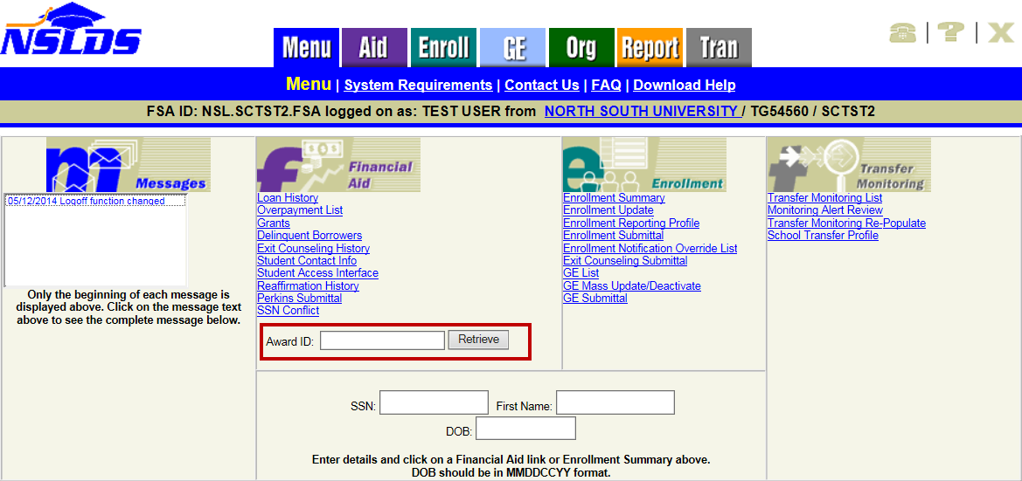
On the Aid tab, the Award ID search is located directly below the search boxes for student identifiers. Additional instructions on the Award ID Search functionality are available in the Menu and Loan History Help pages.
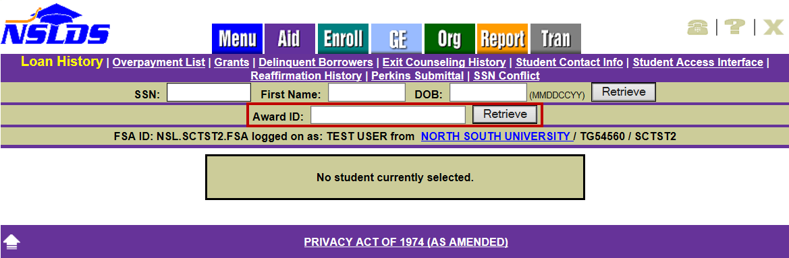
If you don’t know what the Award ID is, you can find it on the Loan Detail page. To locate an Award ID for a specific loan, enter the three borrower identifiers (SSN, Date of Birth, and First Name). Once directed to the Loan History page, click on Loan Detail for the desired loan. The Award ID will be listed in the Details for Loan table on the Loan Detail page.
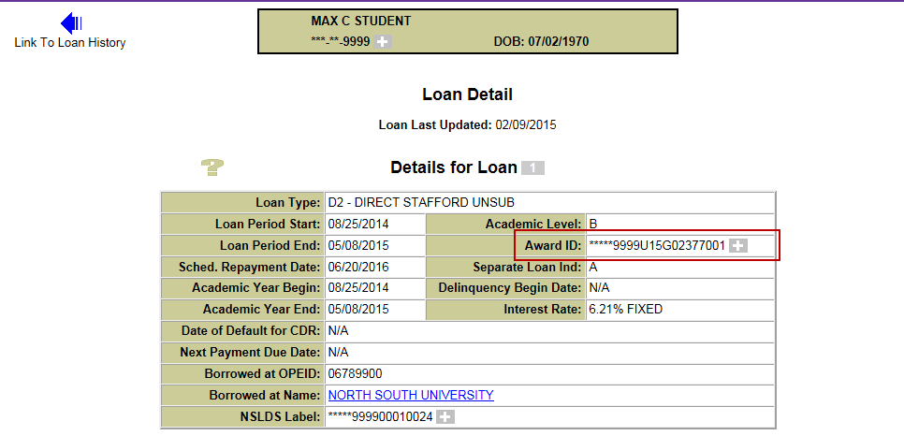
Customer Service Reminder
Please remember to keep your NSLDS Professional Access website ORG contacts current and always list at least a Primary Contact for your organization. It is important to include a Customer Svc (Borrowers) contact as the information is displayed on the NSLDS Student Access website and may be viewed by borrowers and other Federal Student Aid partners.
Additionally, please ensure your school has an Enrollment Reporting contact listed so important notifications related to enrollment reporting compliance are received.
The NSLDS Customer Support Center at 800/999-8219 is available Monday through Friday from 8 A.M. to 9 P.M. (ET). You may also contact Customer Support by email at nslds@ed.gov. Callers in locations without access to 800 numbers may call 785/838-2141.

