Number 61 | November 2018
Summary
This newsletter describes recent enhancements for school users to the NSLDS Professional Access website, including:
- Aid Overpayment Compliance Report
- Aid Overpayment Email Notifications
- Enrollment Reporting (ER) No Certified Programs Report
Aid Overpayment Compliance Report

Aid Overpayment Compliance Report
The new Aid Overpayment Compliance Report was developed after a review of reported and unresolved aid overpayments in NSLDS that exceeded the maximum allowable timeframe for resolving overpayments. This new report will assist schools with determining which aid overpayment records should be updated or deleted on the NSLDS Professional Access website and which should be assigned to the Department of Education (ED) for collection.
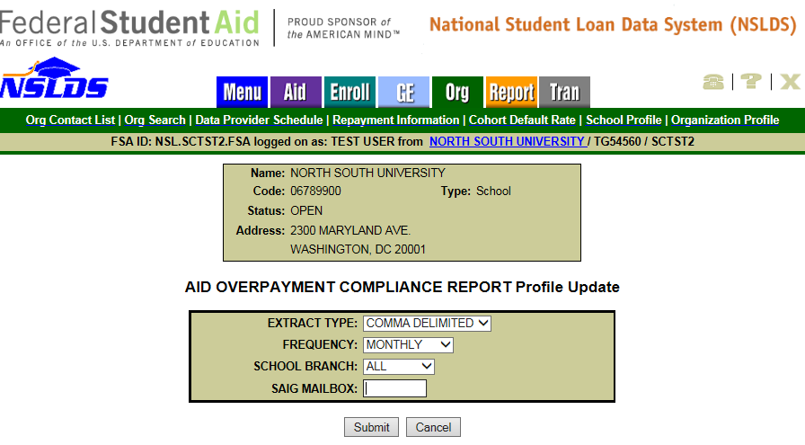
The Aid Overpayment Compliance Report can be scheduled (OVPCL3) for quarterly or monthly distribution. The Scheduled Extract file output is sent to the Student Aid Internet Gateway (SAIG) mailbox designated on the Aid Overpayment Compliance Report scheduling page. The report is sent in the following message classes, based on the requested Extract Type:
- AOCOFWOP (fixed-width Extract Type)
- AOCOCDOP (‘Comma Delimited’ (CSV) Extract Type)
Record layouts for the Aid Overpayment Compliance Report are now available on the NSLDS Record Layouts page of the Information for Financial Aid Professionals (IFAP) website.
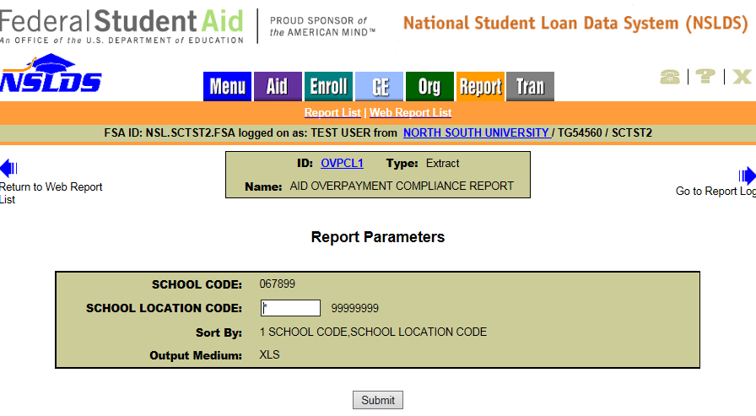
The Aid Overpayment Compliance Report can also be requested as an on-demand report (OVPCL1) under the Web Report List on the Report tab of the NSLDS Professional Access website. When requesting the report, users can leave the asterisk ‘*’ in the School Location Code field to display all data associated with the six-digit OPEID (to include all branch locations) or users can enter their specific eight-digit OPEID associated with their online user ID (to view only data associated with that location).
For more information regarding overpayments, please see Volume 4 (Processing Aid and Managing FSA Funds), Chapter 3 (Overawards and Overpayments) of the Federal Student Aid Handbook.
Aid Overpayment Email Notifications

Aid Overpayment Email Notifications
In the near future, we will begin sending quarterly Aid Overpayment Email Notifications to schools with reported aid overpayments that need to be updated on the NSLDS Professional Access website or assigned to ED for collection. The email notification will come from NSLDS@ED.GOV and will be addressed to the school’s financial aid administrator as provided on the Electronic Application for Approval to Participate in the Federal Student Financial Aid Programs (E-App), and to the Financial Aid Administrator (FAA) Overpayment Issues Contact as provided on the ORG tab of the NSLDS Professional Access website. If your school has not yet provided an Overpayment Issues Contact for each location, please do so as soon as possible. This contact cannot be someone from the school’s third party servicer.
Enrollment Reporting (ER) No Certified Programs Report

Enrollment Reporting (ER) No Certified Programs Report
The new Enrollment Reporting No Certified Programs Report (SCHEP1) provides school users with an extract of students that have appeared on the school’s Enrollment Reporting Roster without a certified program within a specified timeframe for a six-digit School Code or eight-digit School Location Code. The ER No Certified Programs Report includes the current campus-level enrollment information for the student.
Using the Certification Date Begin field, the user chooses a date to limit output to students that have a reported certification on or after the date entered through the date the report is requested. Additionally, the report can be limited to a Social Security Number (SSN) and Last Name range. The report can be sorted by Student SSN only, or by School first, then Student SSN. The report is sent to the SAIG mailbox associated with the NSLDS User ID requesting the report.
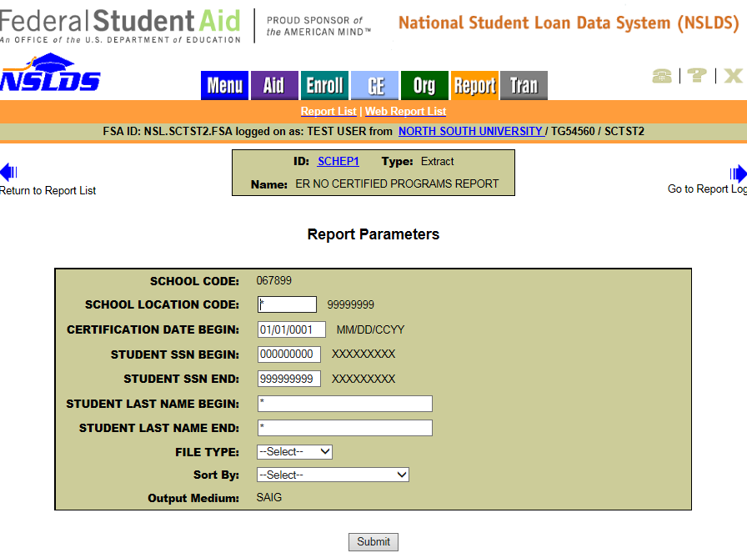
The ER No Certified Programs Report can also be scheduled (SCHEP3) for quarterly or monthly distribution. The initial scheduled report will contain all students at the six-digit School Code or eight-digit School Location Code without a certified program. Each subsequent report will contain the students without certified programs that were certified between the previous month’s or quarter’s report to the date when the report is created. The scheduled report is sent to the SAIG mailbox designated under the Scheduled Reports section of the Organization Profile page, under the ORG tab.
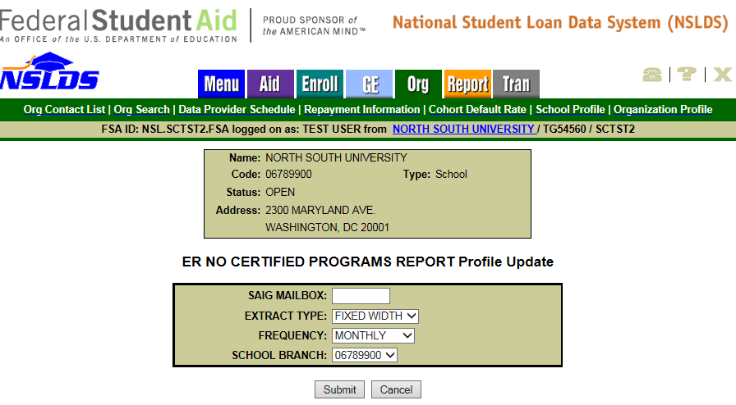
The output for both SCHEP1 and SCHEP3 is sent under message class ERAPFWOP in a fixed-width extract layout. The layout of the reports is identical—with the exception of the Header Record—to the Enrollment Reporting Roster File Record Layouts found in the NSLDS Enrollment Reporting Guide, Appendix A, section A-1. The only difference in the Header Record is that the Header Label field will contain either SCHEP1 or SCHEP3 to identify the report.
Customer Service Reminder
Please remember to keep your NSLDS Professional Access website ORG contacts current and always list at least a Primary Contact for your organization. It is important to include a Customer Svc (Borrowers) contact as the information is displayed on the NSLDS Student Access website and may be viewed by borrowers and other Federal Student Aid partners.
Additionally, please ensure your school has an Enrollment Reporting contact listed so important notifications related to enrollment reporting compliance are received.
The NSLDS Customer Support Center at 1-800-999-8219 is available Monday through Friday from 8 a.m. to 9 p.m. Eastern time (ET). You may also contact Customer Support by email at nslds@ed.gov. Callers in locations without access to 800 numbers may call 785-838-2141.

