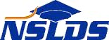 | 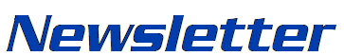
Number 65 | October 2019
Summary
This newsletter describes recent enhancements for school users to the National Student Loan Data System (NSLDS®) Professional Access website. These changes include:
- Automatic Closed School Discharge Code
- New Cancer Treatment Deferment Type Code
- Updated NSLDS Record Layouts
Automatic Closed School Discharge Code

Automatic Closed School Discharge Code

A new Discharge Code (CS02) has been created for Automatic Closed School Discharges. CS02 indicates that the loan has been discharged due to a school closing on or after November 1, 2013 and has been closed for at least three years (and the borrower has met all other criteria for the discharge). The new discharge code appears on the NSLDS Professional Access website under the Aid tab, on the Loan Detail page for the applicable loan. For more information about automatic closed school discharges, refer to the December 13, 2018 Electronic Announcement.
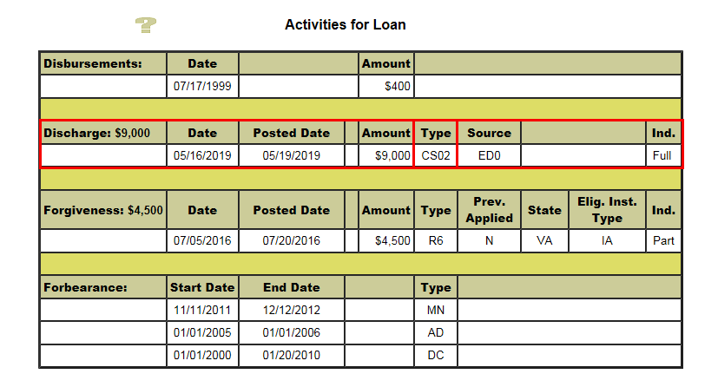
New Cancer Treatment Deferment Type Code

Cancer Treatment Deferment

As described in the August 22, 2019 Electronic Announcement, the Department of Education Appropriations Act, 2019, Title III of Pub.L. 115-245 created a new Cancer Treatment Deferment for borrowers in the William D. Ford Federal Direct Loan (Direct Loan), the Federal Family Education Loan (FFEL), and the Federal Perkins Loan (Perkins Loan) programs.

This new deferment is reported to NSLDS as “CD” and can be viewed on the NSLDS Professional Access website under the Aid tab, on the Loan Detail page for the applicable loan.
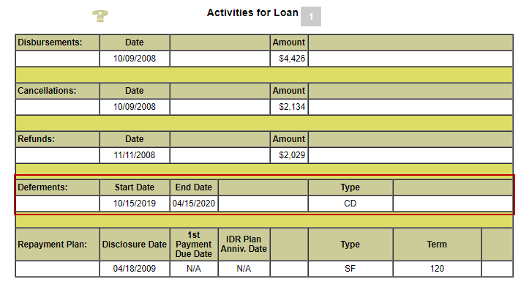

Updated NSLDS Record Layouts
The record layout for the School Portfolio for Schools Report (SCHPR1) (in fixed-width and CSV format) has been updated for both changes and is now available on the NSLDS Record Layouts page of the Information for Financial Aid Professionals (IFAP) website. In addition, the NSLDS Perkins Extract by Parameters (REC005) has been updated for the new “CD” deferment type code and can also be found on the NSLDS Record Layouts page of the IFAP website.

Customer Service Reminder
Remember to keep your NSLDS Professional Access website ORG contacts current and always list at least one Primary Contact for your organization. It is important to include a Customer Svc (Borrowers) contact, as the information is displayed on the NSLDS Student Access website and is viewable by borrowers and other Federal Student Aid partners.
The NSLDS Customer Support Center, at 1-800-999-8219, is available Monday through Friday from 8 a.m. to 9 p.m. Eastern time (ET). Callers in locations without access to 800 numbers may call 785-838-2141. You may also contact Customer Support by email at nslds@ed.gov.

