Number 66 | November 2019
Summary
This newsletter describes recent enhancements to several National Student Loan Data System (NSLDS®) reports available on the NSLDS Professional Access website. These reports include:

- Enrollment Reporting (ER) Graduated/Withdrawn Program Report
- Enrollment Reporting (ER) Statistics Backup Detail Report

Enhancements to Enrollment Reporting (ER) Reports

Enrollment Reporting (ER) Graduated/Withdrawn Program Report
The Enrollment Reporting (ER) Graduated/Withdrawn Program Report (SCHEP4) (formally known as the ER Graduated Programs Report) has been enhanced to include Withdrawn statuses. The report now provides school users with an extract of students and all certified programs with a program enrollment status of Graduated and/or Withdrawn within a specified timeframe. The report can be requested for a six-digit School Code or eight-digit School Location Code. After selecting a Program Status Effective Date range for the report, the user may now select the program enrollment status of Graduated, Withdrawn, or Both. Additionally, the report can be limited to a Social Security Number (SSN) and Last Name range. Sorting Options include Student SSN only or by School Code then Student SSN.
The fixed-width report is sent to the Student Aid Internet Gateway (SAIG) mailbox associated with the FSA User ID requesting the report.
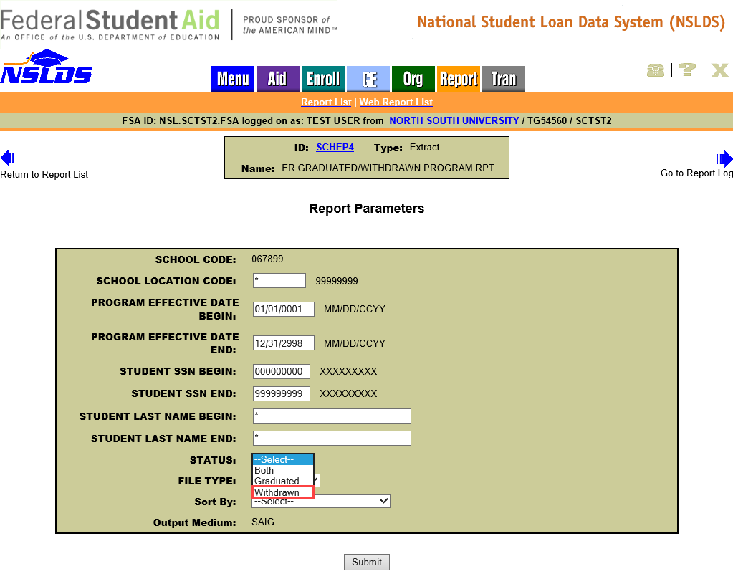
The scheduled version of the report, SCHEP6, has also been updated to include the Withdrawn option and can be scheduled quarterly or monthly. The initial scheduled report contains all students at the six-digit School Code or eight-digit School Location Code, with a certified Graduated and/or Withdrawn program enrollment status. Each subsequent report will contain students who have graduated and/or Withdrawn since the last report was run. The fixed-width report is sent to the SAIG mailbox designated under the Scheduled Reports section of the Organization Profile page.
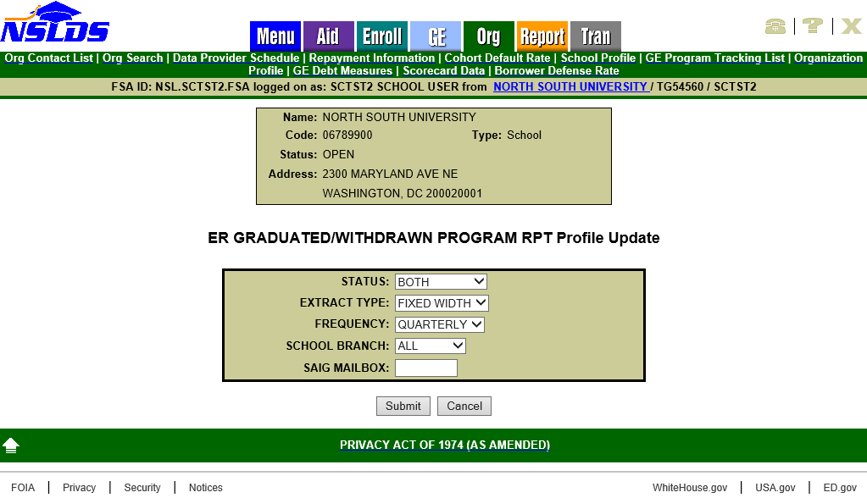
The ad-hoc (SCHEP4) and scheduled (SCHEP6) reports are sent using the message class ERGPFWOP in a fixed-width extract layout. The file layout for this enhanced report is available in the NSLDS Record Layouts section of the Information for Financial Aid Professionals (IFAP) website.

Enrollment Reporting (ER) Statistics Backup Detail Report
The ad-hoc Enrollment Reporting (ER) Statistics Backup Detail Report (SCHCB1) is now also available as a scheduled report (SCHCB3), for monthly distribution. SCHCB3 contains all students at the six-digit School Code or eight-digit School Location Code included in the most recently calculated Enrollment Reporting Statistics. The report is sent in fixed-width or comma separated values (CSV) format via the SAIG to the mailbox designated under the Scheduled Reports section of the Organization Profile page.
Note: As a reminder, the ad-hoc version of this report (SCHCB1) is available in the Report List on the Report tab of the NSLDS Professional Access website. The school may choose to receive all data for all locations associated with its six-digit OPEID by leaving the asterisk (*) in the School Location Code field, or only data for a single location by entering the eight-digit OPEID. The user may choose to sort the report output by SSN or Last/First Name.
The ad-hoc (SCHCB1) and scheduled (SCHCB3) reports are sent using message class ERSBFWOP (fixed-width) and ERSBCDOP (CSV). The file layout for this enhanced report is available in the NSLDS Record Layouts section of the IFAP website.

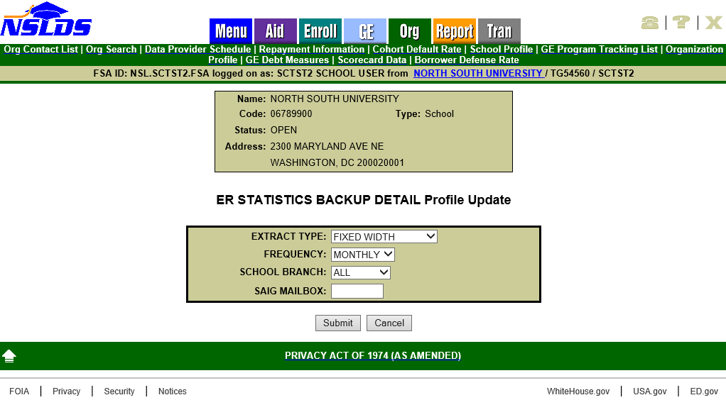
As a reminder, schools may use the Enrollment Reporting Statistics Backup Detail Report to identify which students were not reported with program enrollment information in the latest Enrollment Reporting Statistics calculation, causing the statistics to be lower. Schools with lower than expected program enrollment percentages may research these students to determine if they should have been reported with program enrollment information.
Please note the following specific information about the report:
- Students who were on the school’s roster as of the Start Date, and who were included in the denominator of the Percent Certified with Program Enrollment calculation, are listed on the report.
- The Student Certified with the Program Enrollment indicator field identifies those students that were included in the Percent Certified with Program Enrollment calculation’s numerator, meaning that they were successfully certified with program enrollment information at least once during the evaluation period (Start Date to Evaluation Date).
- The report also identifies students included in the numerator due to ED-approved exceptions, for example, students certified with an enrollment status of X – Never Attended or Z – No Record Found.

An example of the report that has been imported into a spreadsheet with columns labeled is provided below. The Student Certified with Program Enrollment Indicator signifies that the student was included in the numerator when marked with a ‘Y’, and the Numerator Exception Indicator notes where ED-approved exceptions, described earlier, apply.
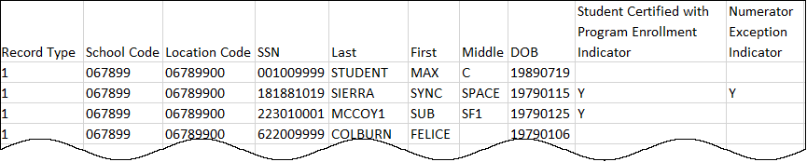
Note that the report can only provide data for the most recently calculated Enrollment Reporting Statistic. Enrollment Reporting Statistics are displayed under the Enrollment Reporting Profile page of the NSLDS Professional Access website.
Reminder: Enrollment Reporting Statistics are calculated during the third week of each month. Only students who were on the school’s enrollment reporting roster as of the Start Date for the evaluation period are included in the calculation. The Start Date is 135 days prior to the Evaluation Date.
Please refer to the NSLDS Enrollment Reporting Guide for more information about Enrollment Reporting Statistics, and for information about other tools and reports that are available to assist schools with Enrollment Reporting. The NSLDS Enrollment Reporting Guide is available in the NSLDS User Documentation section of the IFAP website.
Customer Service Reminder
Please remember to keep your NSLDS Professional Access website ORG contacts current and always list at least a Primary Contact for your organization. It is important to include a Customer Svc (Borrowers) contact as the information is displayed on the NSLDS Student Access website and may be viewed by borrowers and other Federal Student Aid partners.
The NSLDS Customer Support Center at 1-800-999-8219 is available Monday through Friday from 8 a.m. to 9 p.m. Eastern time (ET). You may also contact Customer Support by email at nslds@ed.gov. Callers in locations without access to 800 numbers may call 785-838-2141.

