Number 67 | January 2020
Summary
This newsletter describes recent enhancements for school users to the National Student Loan Data System (NSLDS®) Professional Access website. These changes include two new reports:
- Enrollment Reporting (ER) Graduated/Withdrawn Campus Report (SCHEC1)
- Death Status Conflict Report (DSCSC1)
New Reports

Enrollment Reporting (ER) Graduated/Withdrawn Campus Report (SCHEC1)

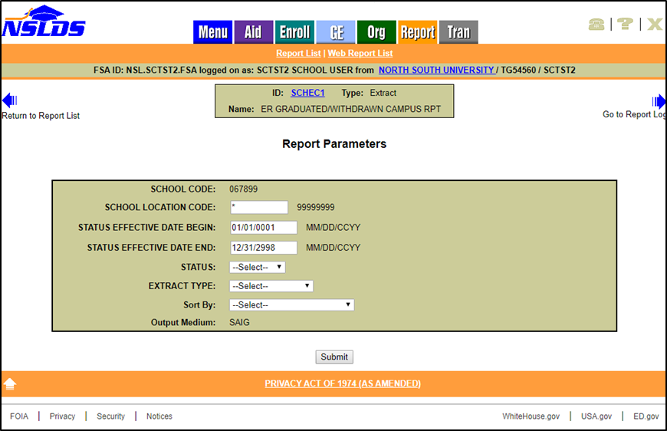
The new Enrollment Reporting (ER) Graduated/Withdrawn Campus Report (SCHEC1) provides school users with an extract of all students certified with a campus enrollment status of Graduated and/or Withdrawn within a specified timeframe. The report can be requested for a six-digit School Code or eight-digit School Location Code. After selecting a Status Effective Date Begin range, the user may select the campus enrollment status of Graduated, Withdrawn, or Both. Additionally, the report may be sorted by Student SSN only or by School Code then Student SSN.
The report is sent to the Student Aid Internet Gateway (SAIG) mailbox associated with the FSA User ID requesting the report.
The ER Graduated/Withdrawn Campus Report (SCHEC3) can also be scheduled for quarterly or monthly distribution. The initial scheduled report contains all students at the six-digit School Code or eight-digit School Location Code with a certified Graduated and/or Withdrawn campus enrollment status. Each subsequent report will contain students who graduated and/or withdrew since the last report was run. The report is sent to the SAIG mailbox designated under the Scheduled Reports section of the Organization Profile page.
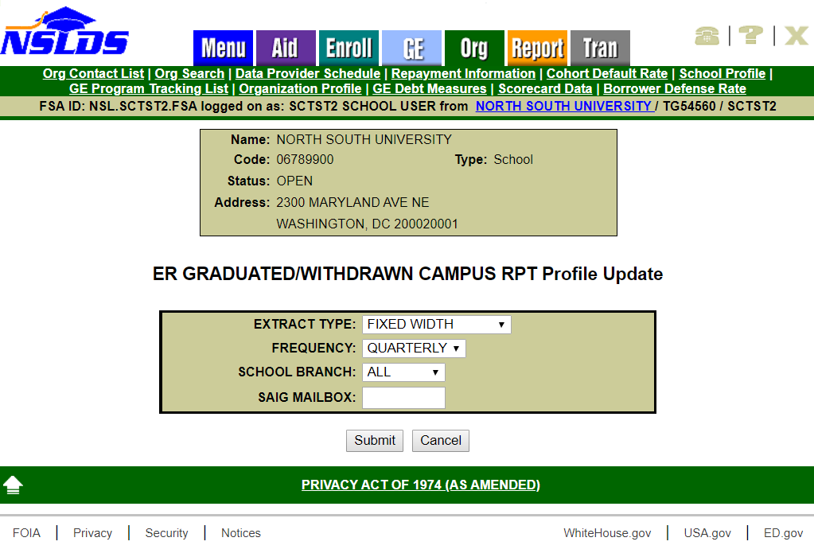
The Ad-hoc (SCHEC1) and Scheduled (SCHEC3) reports are sent using message class ERGCFWOP (fixed-width) or ERGCCDOP (CSV). The file layout for this new report is available in the NSLDS Record Layouts section of the IFAP website.

Death Status Conflict Report (DSCSC1)

The new Death Status Conflict Report (DSCSC1) provides school users with an extract of borrowers who have a loan in an open status at the specified school and also have at least one loan in a death status at any entity. The user may choose to receive all data for the school associated with their NSLDS user ID by leaving the asterisk (*) in the School Location Code field, or only data for a specific location of the school by entering the eight-digit OPEID for that location. The user will only indicate the extract type (fixed width or comma delimited). The report output is sorted by SSN and delivered to the SAIG mailbox associated with the requesting user.

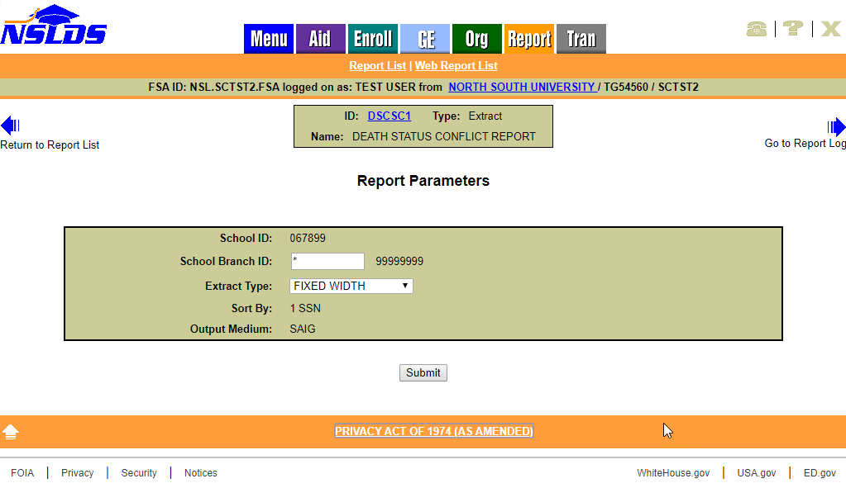
The Death Status Conflict Report (DSCSC2) can also be scheduled for quarterly or monthly distribution. The user who sets up scheduling may choose to receive all data for the school associated with their NSLDS user ID or only data for the specific location associated with their ID. The scheduled report will be sent to the SAIG mailbox (TG number) specified by the user.
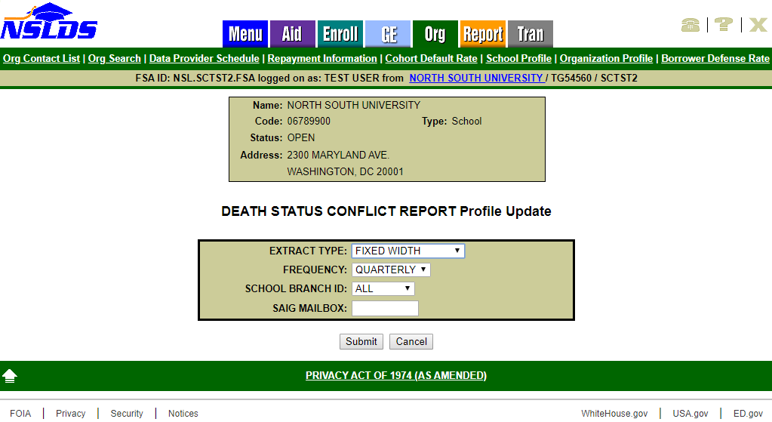
The extract file output for both reports is sent using message class DERPFWOP (fixed width) or DERPCDOP (CSV). The file layout for this new report is available in the NSLDS Record Layouts section of the IFAP website.
Customer Service Reminder
Please remember to keep your NSLDS Professional Access website ORG contacts current and always list at least a Primary Contact for your organization. It is important to include a Customer Svc (Borrowers) contact as the information is displayed on the NSLDS Student Access website and may be viewed by borrowers and other Federal Student Aid partners.
The NSLDS Customer Support Center at 1-800-999-8219 is available Monday through Friday from 8 a.m. to 9 p.m. Eastern time (ET). You may also contact Customer Support by email at nslds@ed.gov. Callers in locations without access to 800 numbers may call 785-838-2141.

