Number 68 | April 2020
Summary
This newsletter describes recent enhancements for school users to the National Student Loan Data System (NSLDS®) and the NSLDS Professional Access website. These changes include:
- 2020 Classification of Instructional Programs (CIP) Codes
  - 2020 CIP Codes
  - Reporting 2020 CIP Year via SAIG Batch Enrollment Reporting and Spreadsheet Submittal Processes
  - Enrollment Maintenance Page on the NSLDS Professional Access Website
- Program Identifier Changes for Enrollment Reporting
  - Program Identifier Changes via SAIG Batch Enrollment Reporting and Spreadsheet Submittal
  - Enrollment History Update Page on the NSLDS Professional Access Website
- New Enrollment Reporting Edits
- CIP Year display on the NSLDS Professional Access website
- New Enrollment Reports
  - Enrollment Reporting 2020 Invalid CIP Codes Report (SCHCP4)
  - Enrollment Reporting Deleted CIP Codes Report (SCHDC1)
  - Enrollment History Report (SCHHS1)
- Enhancements to the Enrollment Reporting Statistics
  - New 2020 CIP Code Statistics
2020 Classification of Instructional Programs (CIP) Codes
2020 CIP Codes
The Classification of Instructional Programs (CIP) is a set of codes that define fields of study and are maintained by the Department's National Center for Education Statistics (NCES). CIP Codes were last updated in 2010 and are usually updated every 10 years. Schools may now report 2020 CIP Codes through Student Aid Internet Gateway (SAIG) batch submissions, spreadsheet submittal uploads, and using the Enrollment Maintenance page of the NSLDS Professional Access website. Schools are encouraged to refer to the NCES website for a full listing of 2020 CIP Codes to begin reporting in the Enrollment Reporting Roster.
Reporting 2020 CIP Year via SAIG Batch Enrollment Reporting and Spreadsheet Submittal Processes
For purposes of enrollment reporting, a program’s identifiers are a combination of the school’s eight-digit OPEID, the CIP Year, the CIP code, the Credential Level, and the Published Program Length in Years. When a school has determined the only change to a student’s enrollment program is the CIP Year, the updated 2020 CIP Year can be submitted in the Program-Level Enrollment Record (Record Type 002), which instructs NSLDS to perform an auto-conversion on behalf of the school.
An auto-conversion occurs when a previously reported school-certified 2000 or 2010 CIP Year program is now reported with a 2020 CIP Year (all program identifiers except CIP Year are identical) to NSLDS. The auto-conversion means that NSLDS will transfer the active enrollment history from the 2000 or 2010 CIP program to the 2020 CIP program and apply ‘X’ (Never Attended) as the most current, active enrollment status for the 2000 or 2010 CIP program. Additionally, all the previously active enrollment history on the 2000 or 2010 CIP program is set to inactive.
The following example is a display of Active and Inactive Records on the Program Enrollment Detail Page of a student’s program enrollment history after a 2020 CIP Year auto conversion has occurred.
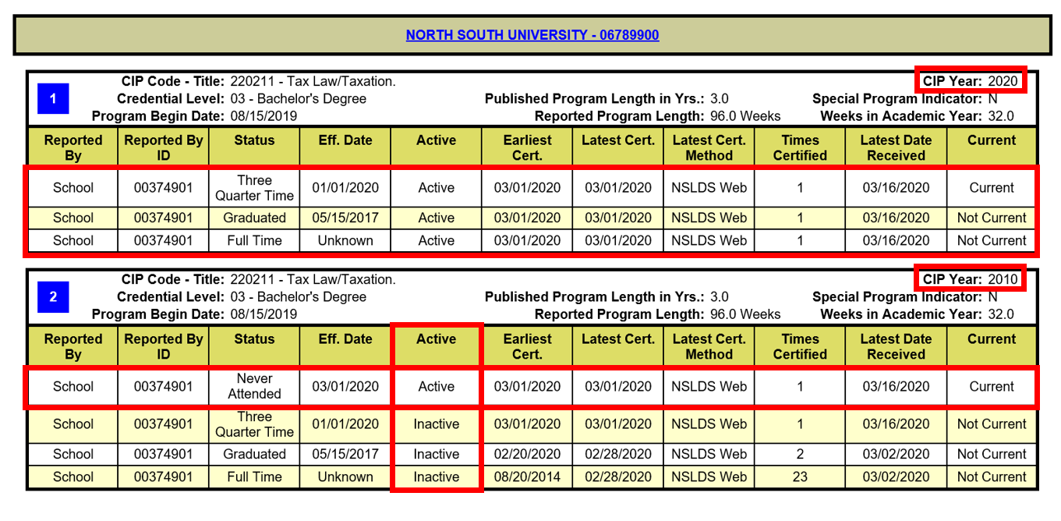
Furthermore, after a school reports a program with a 2020 CIP Year (which triggers an auto-conversion) and the same corresponding 2010 CIP Year program is sent to NSLDS by the Common Origination and Disbursement (COD) System (all program identifiers except CIP Year are identical), NSLDS will not include the COD 2010 CIP program on the roster due to the existence of an auto-conversion. This ensures that the program is not duplicated.

Enrollment Maintenance Page on the NSLDS Professional Access Website
The Enrollment Maintenance Page on the NSLDS Professional Access website has been enhanced to allow schools to report 2020 CIP Year online. The Enrollment Maintenance Page can be accessed from either the Enrollment Summary or the Enrollment Update pages under the Enroll tab.
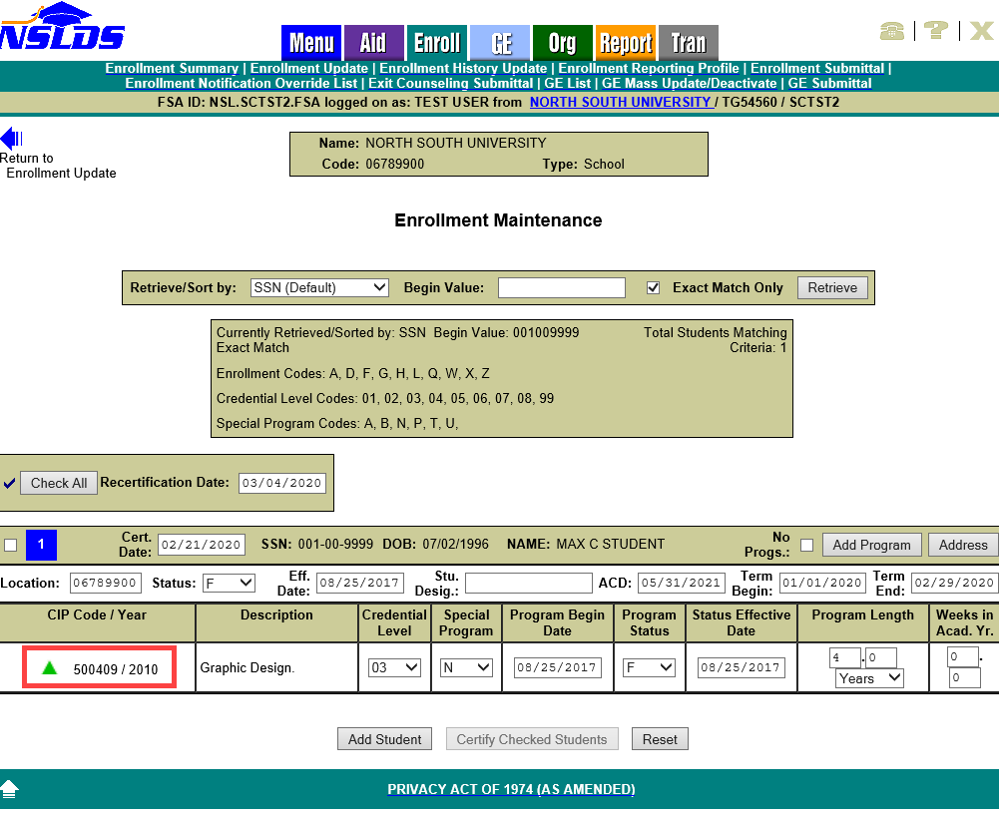
The Enrollment Maintenance Page now displays the CIP Year of an enrollment program next to each CIP Code. Any CIP Year older than 2020 is identified with a green triangular 2020 CIP Year Auto-Conversion icon to the left of the CIP Code and CIP Year combination.
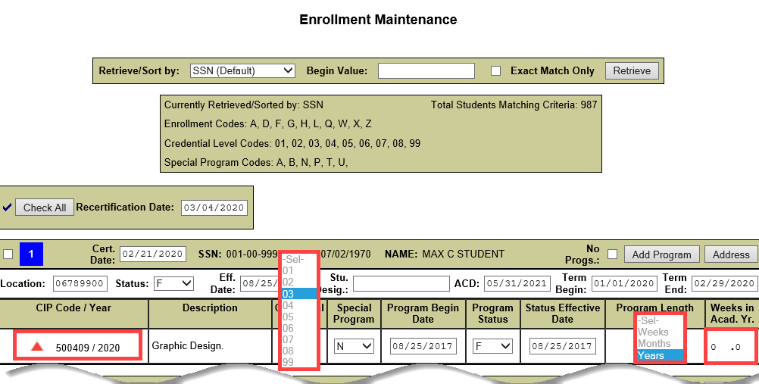
When selected, the 2020 CIP Year Auto-Conversion icon changes from green to a triangular red icon and sets the CIP Year to 2020. When the 2020 CIP Year Auto-Conversion icon is red, no changes to the CIP Code, Credential Level, Program Length, or Weeks in Academic Year are allowed, preventing a new unique program from being created, while changes to the Special Program, Program Begin Date, Program Status, and/or Status Effective Date are still accepted. After confirmation and certifying the student(s), an auto-conversion occurs and NSLDS transfers the active enrollment history from the 2000 or 2010 CIP program to the 2020 CIP program and applies ‘X’ (Never Attended) as the most current, active enrollment status for the 2000 or 2010 CIP program. Additionally, all the previously active enrollment history on the 2000 or 2010 CIP program is set to inactive.
The user may only revert to the original values for the program prior to submission by clicking on the red triangular icon again. The action will change the triangular icon from red back to green and sets the CIP Year back to 2000 or 2010 as applicable.
Please note, not all programs with a CIP Year of 2000 or 2010 have an equivalent 2020 CIP Code. If this is the case, upon certifying the student, Error 60 (Please ensure CIP Code is valid) will be produced. These programs will need to be updated using the new Program Identifier Change functionality described in the next section of this Newsletter.
Program Identifier Changes for Enrollment Reporting
Program Identifier Changes via SAIG Batch Enrollment Reporting and Spreadsheet Submittal
As mentioned above, a program’s identifiers are a combination of the school’s eight-digit OPEID, the CIP Year, the CIP code, the Credential Level, and the Published Program Length in Years. A change or correction to the reported value in any of the program identifiers causes a new program to be created. Previously, to make a correction, the school needed to inactivate the program with incorrect data by reporting it with a Program-Level Enrollment Status of ‘X’ – Never Attended and then report the new program with all associated program enrollment history.
Enrollment Reporting has been enhanced to allow schools to report Program Identifier Changes. NSLDS Enrollment Reporting File Layouts have been updated to include the Current/New Program Identifier Change Record (Record Type 004) for reporting through SAIG Batch submissions and the Spreadsheet Submittal process.
As shown in the fixed-width Current/New Program Identifier Change Record layout (Record Type 004) below, all records in a bundle must have the same values for Student Current SSN and OPEID and the school must provide all identifiers for the Current Program as well as the New Program. The Current Program is the program the school has already successfully reported to NSLDS and the school is needing to correct, whether the program is currently on the roster or may have been on the roster at some point in the past. The New Program is the program with the corrected identifiers. Please note that the New Program cannot be the same as an existing program for the student on NSLDS.
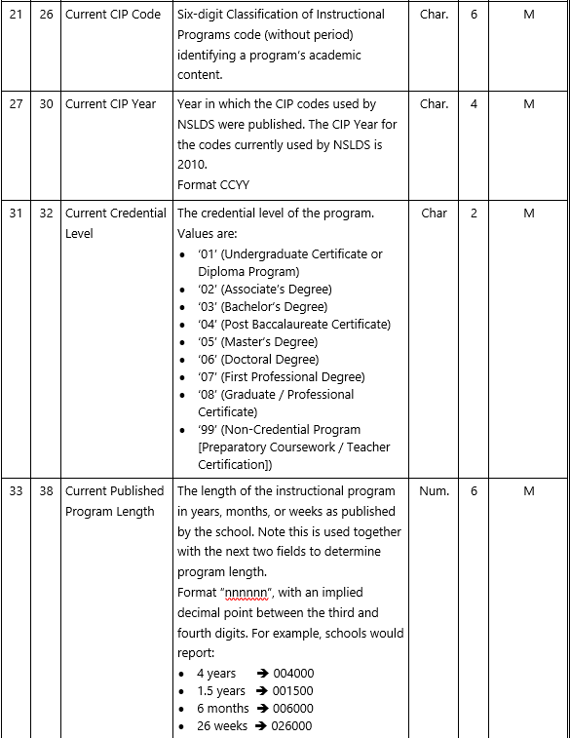
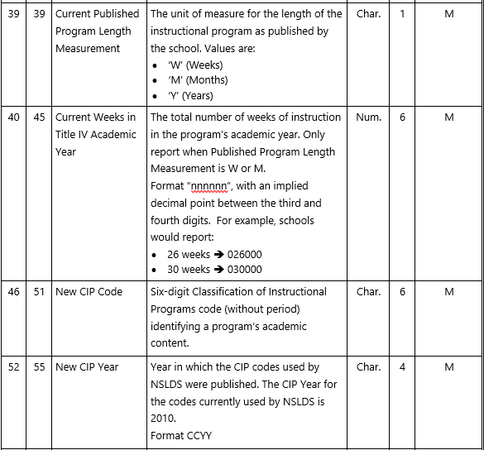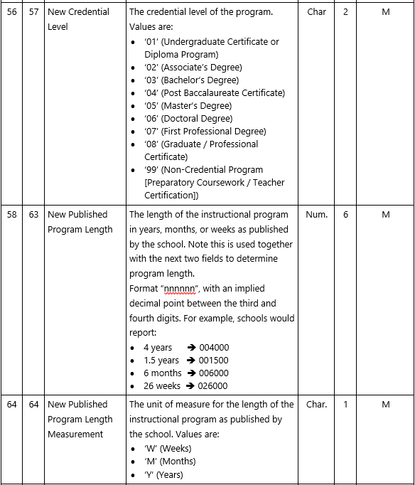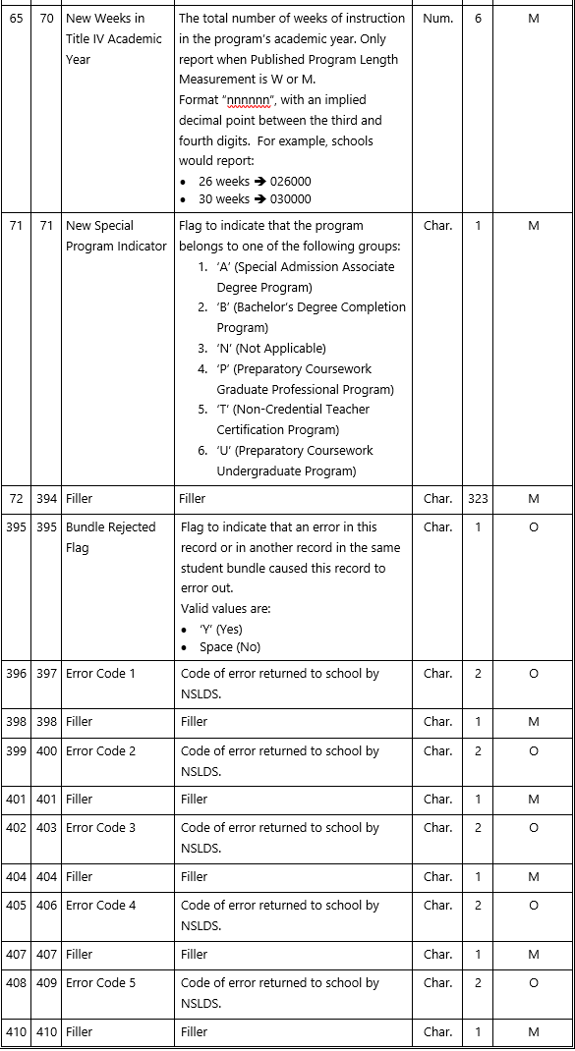A Program Identifier Change works like an auto-conversion. NSLDS transfers the active enrollment history from the Current Program to the New Program and applies ‘X’ (Never Attended) as the most current, active enrollment status for the Current Program. Additionally, all the previously active enrollment history on the Current Program is set to inactive.
Note: All records must be reported for a given student. All records in a bundle must have the same values for Student Current SSN and OPEID for each detail record type. Additionally, records for a given student in a single bundle must be grouped together and ordered by record type.
The updated NSLDS Enrollment Reporting Roster File Record Layouts and updated Enrollment Spreadsheet Submittal Format are available on the Information for Financial Aid Professionals (IFAP) website.
Enrollment History Update Page on the NSLDS Professional Access Website
The Enrollment History Update Page on the NSLDS Professional Access website has been enhanced to allow schools to report Program Identifier Changes. The Enrollment History Update page can be accessed from the Menu page or under the Enroll tab. The Program Enrollment section of the page now displays a button to Change Identifiers and CIP Year next to each CIP Code for each program. An informational icon with ‘Pre-2020 CIP Year’ will display when a program’s CIP Year is 2000 or 2010.
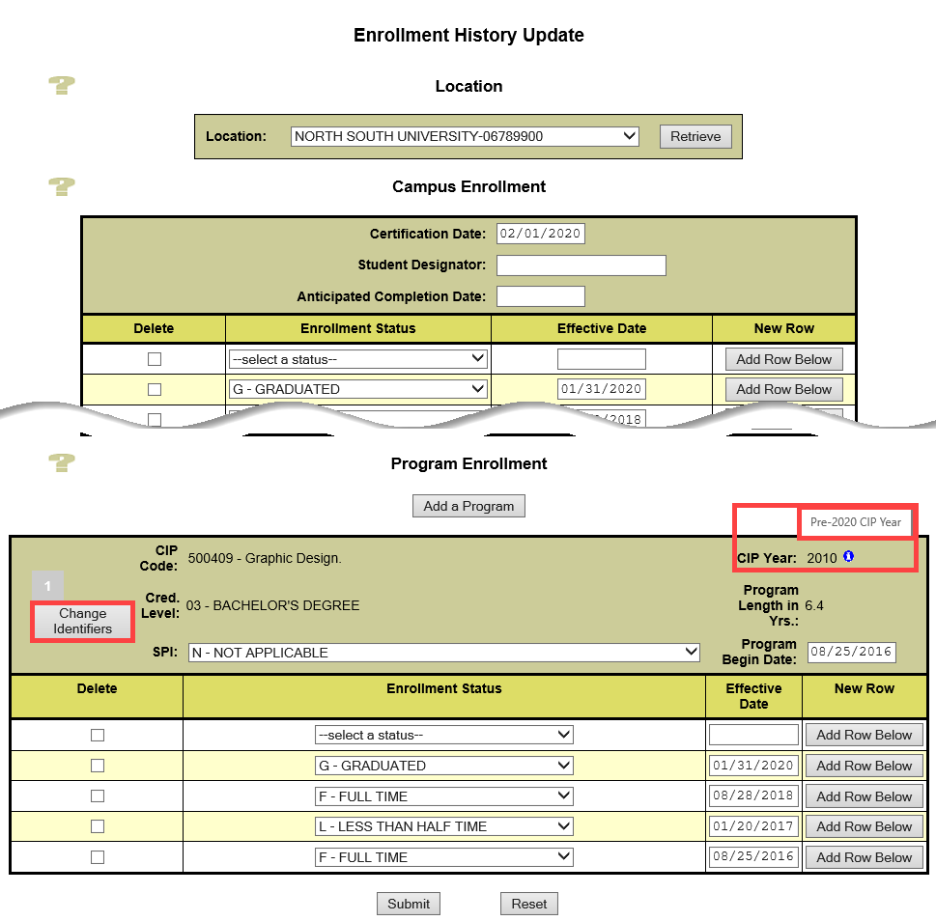
In the example displayed above, the school reported the student’s Graphic Design Published Program Length in Years as 6.4 instead of 4 years. To update the Published Program Length in Years and/or any other program identifiers, click the Change Identifiers button. After clicking the Change Identifiers button, the program identifier fields (CIP Code, CIP Year, Credential Level, and Program Length in Years) are no longer viewable as display only and can be updated, as shown below.
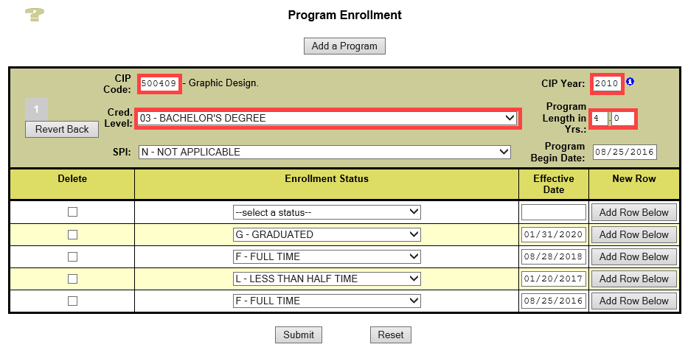
When the Change Identifiers button is clicked, a Revert Back button displays to allow users the option to undo changes before submitting. Clicking the Revert Back button will redisplay the Enrollment History Update page with the CIP Code, CIP Year, Credential Level, Program Length in Years, Special Program Indicator, and Program Begin Date values as displayed when the page was initially populated.
After submitting and certifying the changes, a Program Identifier Change works like an auto-conversion. NSLDS transfers the active enrollment history from the 2000 or 2010 CIP program to the 2020 CIP program and applies ‘X’ (Never Attended) as the most current, active enrollment status for the 2000 or 2010 CIP program. Additionally, all the previously active enrollment history on the 2000 or 2010 CIP program is set to inactive.
New Enrollment Reporting Edits
The following new edits have been added to ensure accurate reporting of 2020 CIP Year and Program Identifier Changes:
- Error 80 is used when a Program Identifier Change (Record Type 004) is reported with the following situations:
- New Program reported is a New Program in another reported Program Identifier Change Record for the same student
- New Program reported is a Current Program in another reported Program Identifier Change Record for the same student
- New Program reported is an active Current Program on NSLDS
- New Program reported is an active program reported on the Program-Level Record for the same student
- Error 81 is used when a Program Identifier Change (Record Type 004) is reported with the following situations:
- Current Program reported is a Current Program in another reported Program Identifier Change Record for the same student
- Current Program reported is a New Program in another reported Program Identifier Change Record for the same student
- Current Program reported is not an active program on NSLDS or program reported in the Program-Level Record for the same student
- Current Program with a non-2020 CIP Year matches an active program with a 2020 CIP year reported in the Program-Level Record.
- Error 82 is used when 2020 CIP Year (Record Type 002) and/or Program Identifier Changes (Record Type 004) are reported with the following situations:
- Non-2020 CIP Year program reported in the Program-Level Record is the same program with a 2020 CIP Year in the same bundle
- Non-2020 CIP Year program reported in the Program-Level Record already exists with a 2020 CIP Year on NSLDS for the same student
- 2020 CIP Year program reported has the same program identifiers as multiple non-2020 CIP Year (i.e., 2000 and 2010) programs on NSLDS for the same student
CIP Year display on the NSLDS Professional Access Website
CIP Year Displays on the NSLDS Professional Access Website
The NSLDS Professional Access website has been enhanced to display the CIP Year of an Enrollment Reporting program. This new feature allows school users to view not only the reported CIP Code but also the CIP Year associated with the program.
The CIP Year now displays on the following pages of the NSLDS Professional Access website:
- Enrollment Maintenance
- Program Enrollment Detail
- Program Certification Detail
- Subsidized Usage
- Maximum Eligibility Timeline
- Enrollment History Update
Additionally, CIP Year has been added to the Program Enrollment Advanced Search Options on the Enrollment Update page to assist schools in filtering program enrollment information on the Enrollment Maintenance Page for students attending their school.
New Enrollment Reports
Enrollment Reporting 2020 Invalid CIP Codes Report (SCHCP4)
The new Enrollment Reporting (ER) 2020 Invalid CIP Codes Report (SCHCP4) provides school users with an extract of current students enrolled in a program with a CIP Year of 2000 or 2010. The report assists schools in determining which students have programs that need to be updated to the equivalent CIP Year 2020. Users may refer to the NCES website to obtain 2020 CIP Codes. The report can be requested for a six-digit School Code or eight-digit School Location Code. The user may choose to receive all data associated with their school by leaving the asterisk (*) in the School Location Code or receive data for a single location by entering the eight-digit OPEID in the School Location Code. The user can indicate whether to include students currently enrolled in programs with CIP Year 2000 and/or 2010 that have equivalent 2020 CIP Year programs.
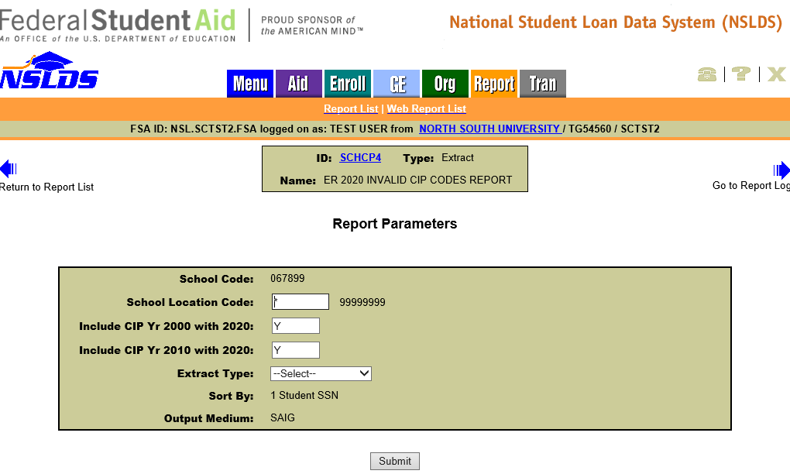
The report output is sorted by SSN and formatted using Extract Type options of Fixed-Width, sent in message class OLCIPFOP, or Comma Delimited, sent in message class OLCIPCOP. The report is delivered to the SAIG mailbox (TG number) associated with the FSA User ID that requested the report. The extract file layouts are available in the NSLDS Record Layouts section of the IFAP website.
Enrollment Reporting Deleted CIP Codes Report (SCHDC1)
The new Enrollment Reporting (ER) Deleted CIP Code Report (SCHDC1) provides school users with an extract of current students enrolled in a program with a CIP Year 2000 or 2010. The report assists schools in determining which students have programs with deleted CIP codes for the CIP Year 2020. Users may refer to the NCES website to obtain 2020 CIP Codes. The report can be requested for a six-digit School Code or eight-digit School Location Code. The user may choose to receive all data associated with their school by leaving the asterisk (*) in the School Location Code or receive data for a single location by entering the eight-digit OPEID in the School Location Code. The user can indicate whether to include students currently enrolled in programs with a CIP Year 2000 and/or 2010 that do not have equivalent 2020 CIP Year programs.
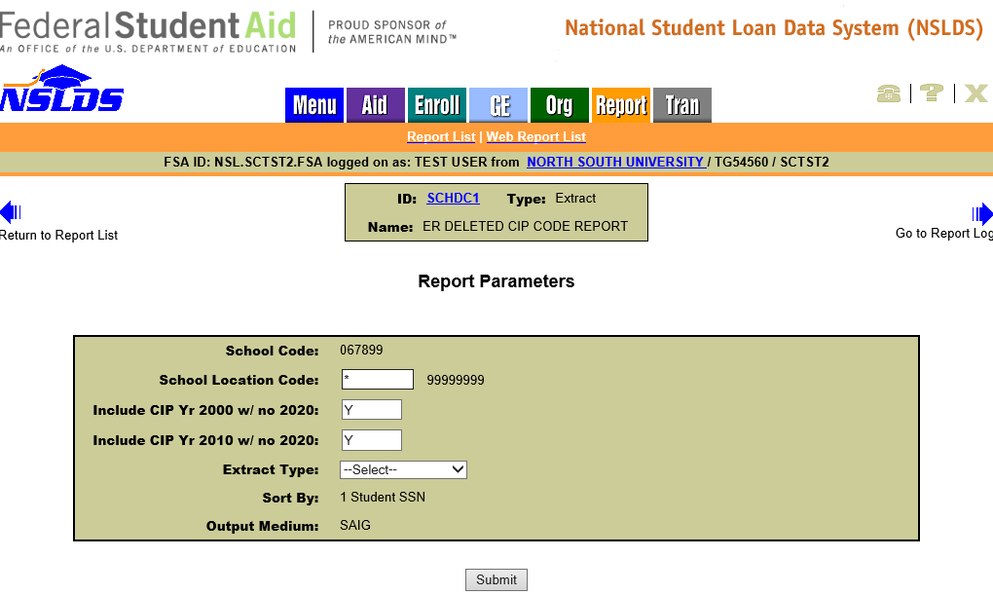
The report output is sorted by SSN and formatted using Extract Type options of Fixed-Width, sent in message class DLCIPFOP, or Comma Delimited, sent in message class DLCIPCOP. The report is delivered to the SAIG mailbox (TG number) associated with the FSA User ID that requested the report. The extract file layouts are available in the NSLDS Record Layouts section of the IFAP website.
Enrollment History Report (SCHHS1)
The new Enrollment History Report (SCHHS1) provides school users with an extract of all school certified active campus and program enrollment history at a given school or location. The report can be requested for a six-digit School Code or eight-digit School Location Code. The user may choose to receive all data associated with their school by leaving the asterisk (*) in the School Location Code or receive data for a single location by entering the eight-digit OPEID in the School Location Code. The report can be limited to a Social Security Number (SSN) and Last Name range. The user can also indicate a date range for Campus Effective Date and Program Effective Date for campus and program enrollment history. Additionally, the user may choose to receive all programs associated with their school by leaving the asterisk (*) in the CIP Code and Credential Level fields, or limit output to a specific CIP Code and credential level. The user may also indicate a specific length range for the Published Program Length in Years.
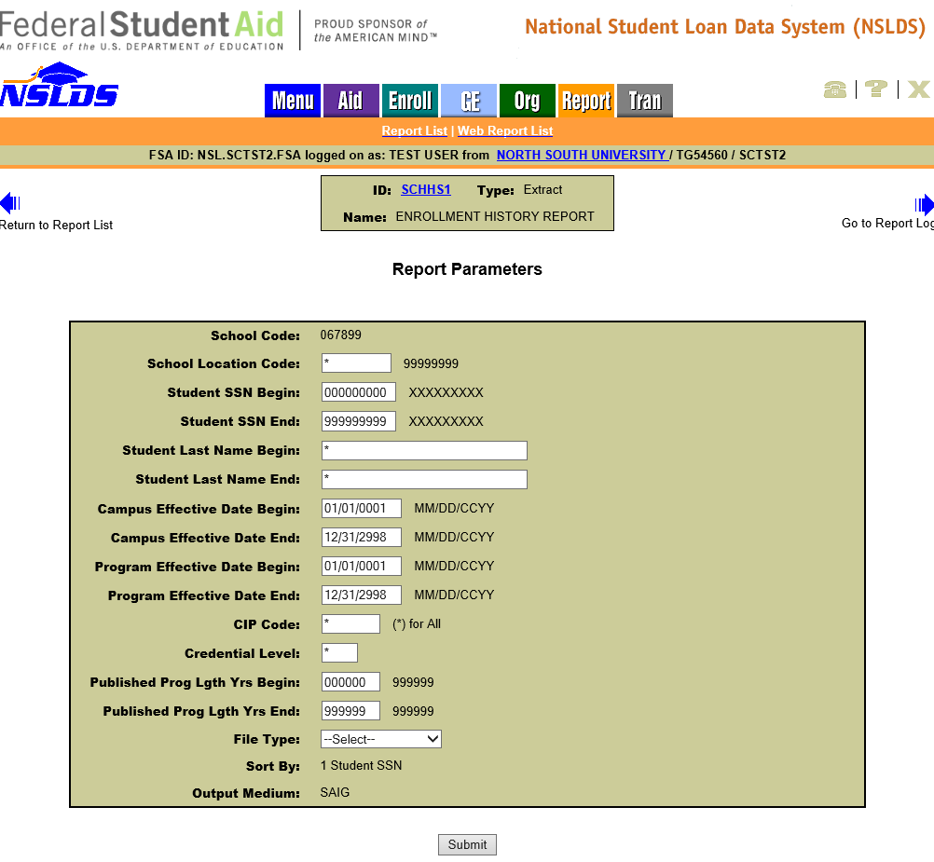
The report output is sorted by SSN and formatted using Extract Type options of Fixed-Width, sent in message class ERHISFOP, or Comma Delimited, sent in message class ERHISCOP. The report is delivered to the SAIG mailbox (TG number) associated with the FSA User ID that requested the report. The detail records are identical to the updated Enrollment Reporting Roster Layouts. Please see the NSLDS Enrollment Reporting Guide for reporting and field details. The Enrollment Reporting Guide is available in the NSLDS User Documentation section on IFAP.
Enhancements to the Enrollment Reporting Statistics
New 2020 CIP Code Statistics
The Enrollment Reporting Statistics have been enhanced to track whether a school has reported programs with a 2020 CIP Year for the students on its Enrollment Reporting Roster. NSLDS determines Programs Certified with Active Enrollment, Programs Certified with 2020 CIP Year, and Percent Program Certified with 2020 CIP Year by calculating the total number of programs certified with active enrollment (enrollment statuses of ‘F’, ‘Q’, ‘H’, ‘L’, and ‘A’) on the Start Date and number of programs certified, at least once, with active enrollment, where CIP Year was 2020, within the current evaluation period.
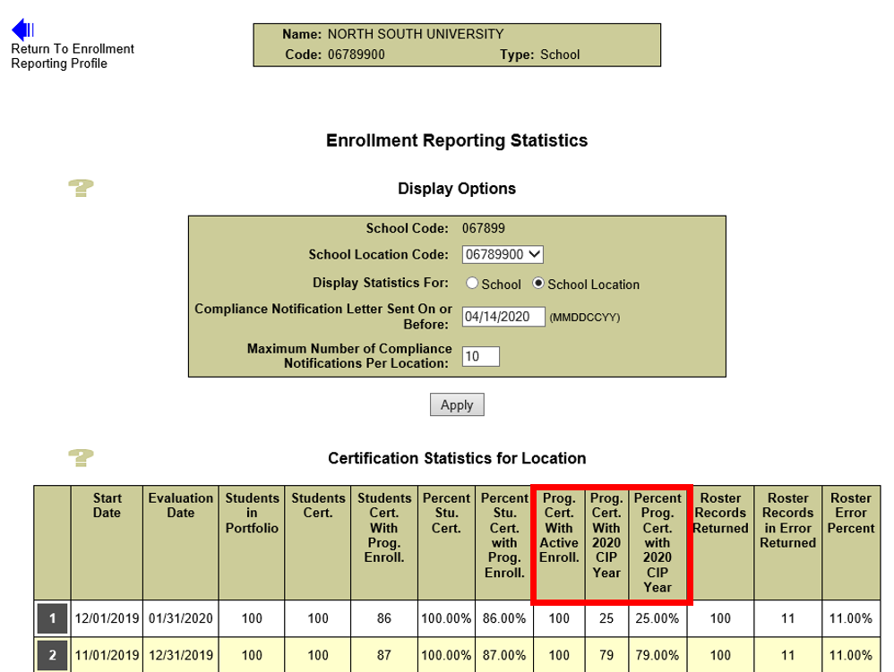
Schools can view the new 2020 CIP Code Statistics in the Certification Statistics for Location table on the Enrollment Statistics Page, located under Enrollment Reporting Profile in the Enroll tab. Schools are encouraged to refer to the NCES website for a full listing of 2020 CIP Codes and take the necessary action to ensure that 2020 CIP Year programs are reported for all currently enrolled students. Additionally, the new Enrollment Reporting (ER) Deleted CIP Code Report (SCHDC1) assists schools in determining which students have programs with deleted CIP codes for the CIP Year 2020.
Furthermore, the Enrollment Statistics Report (ENLST1), which contains the same information that is displayed on the Enrollment Reporting Statistics page, has been updated to include the new 2020 CIP Code Statistics. This report provides school users with Enrollment Statistics for the school code or school location code associated with the user's ID. The report includes information about completeness and quality of the enrollment reporting provided by schools participating in the federal student aid programs. The report is available to request on the Report tab and is delivered on-demand in a browser window using MS ExcelTM format.
Customer Service Reminder
Please remember to keep your NSLDS Professional Access website ORG contacts current and always list at least a Primary Contact for your organization. Additionally, for all NSLDS data providers, it is important to include a Customer Svc (Borrowers) contact as the information is viewed on the StudentAid.gov website for student customers while also being used by other Federal Student Aid partners.
Additionally, please ensure your school has an Enrollment Reporting contact listed so that important notifications related to enrollment reporting compliance are received.
The NSLDS Customer Support Center can be reached at 1-800-999-8219 or by email at nslds@ed.gov and is available Monday through Friday from 8 a.m. to 9 p.m. Eastern time (ET). Callers in locations without access to 800 numbers may call 785-838-2141.

